**CAPESTONE PROJECT-1**

**POST GRADUATE PROGRAM IN DEVOPS**

**NAME : SIDDOJU RAVI MOHAN**

**MAIL : ravimohans1@gmail.com**

**Mobile :7337056757**

**Registration ID:**

**https://github.com/siddojuravi/ravimohan-capstone-project.git**

**Infra Optimization.**

Course-end Project 1

DESCRIPTION

Create a DevOps infrastructure for an e-commerce application to run on high-availability mode.

**Background of the problem statement:**  
A popular payment application, **EasyPay**where users add money to their wallet accounts, faces an issue in its payment success rate. The timeout that occurs with  
the connectivity of the database has been the reason for the issue.  
While troubleshooting, it is found that the database server has several downtime instances at irregular intervals. This situation compels the company to create their own infrastructure that runs in high-availability mode.  
Given that online shopping experiences continue to evolve as per customer expectations, the developers are driven to make their app more reliable, fast, and secure for improving the performance of the current system.

**Implementation requirements:**

1. Create the cluster (EC2 instances with load balancer and elastic IP in case of AWS)
2. Automate the provisioning of an EC2 instance using Ansible or Chef Puppet
3. Install Docker and Kubernetes on the cluster
4. Implement the network policies at the database pod to allow ingress traffic from the front-end application pod
5. Create a new user with permissions to create, list, get, update, and delete pods
6. Configure application on the pod
7. Take snapshot of ETCD database
8. Set criteria such that if the memory of CPU goes beyond 50%, environments automatically get scaled up and configured

**The following tools must be used:**

1. EC2
2. Kubernetes
3. Docker
4. Ansible or Chef or Puppet

**The following things to be kept in check:**

1. You need to document the steps and write the algorithms in them.
2. The submission of your GitHub repository link is mandatory. In order to track your tasks, you need to share the link of the repository.
3. Document the step-by-step process starting from creating test cases, then executing them, and recording the results.
4. You need to submit the final specification document, which includes:

* Project and tester details
* Concepts used in the project
* Links to the GitHub repository to verify the project completion
* Your conclusion on enhancing the application and defining the USPs (Unique Selling Points)

**1.Create the cluster (EC2 instances with load balancer and elastic IP in case of AWS)**

**Launch EC2 instances**

**Click on launch instance**

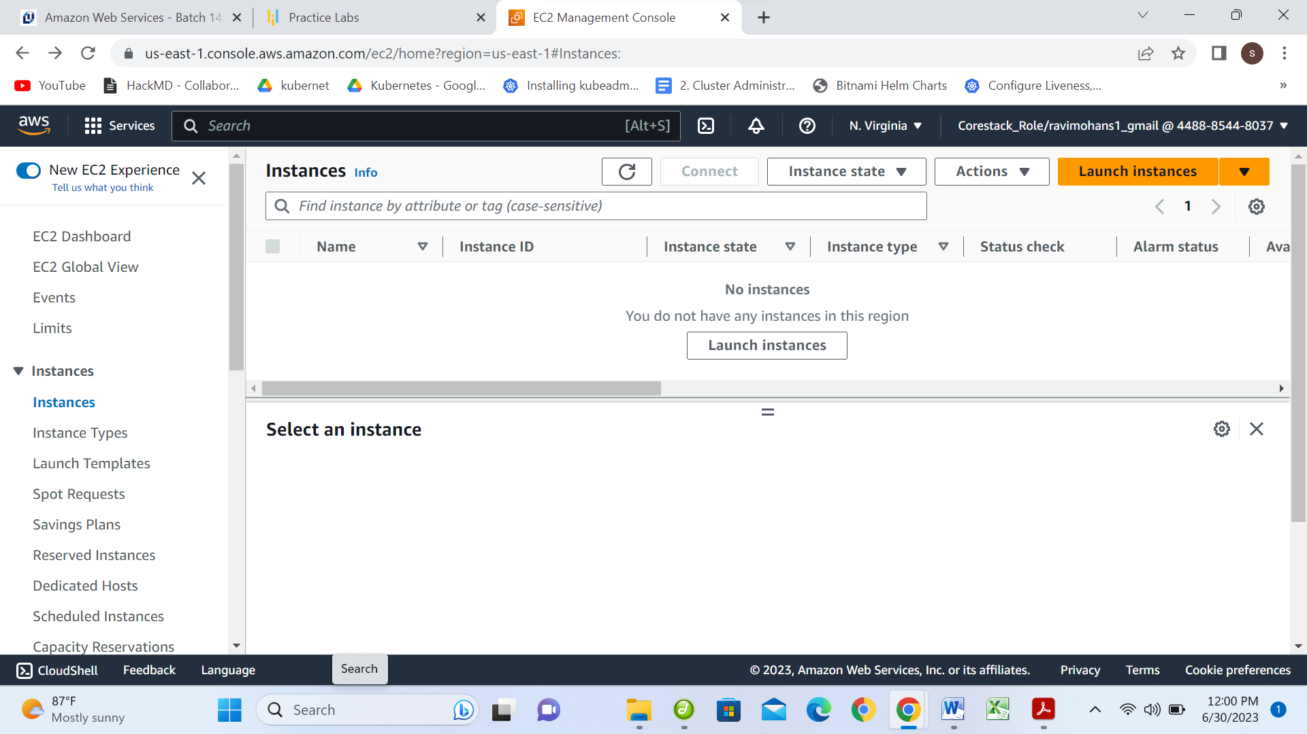

**Give instance Name: Easypay-1 & Number of Instances:2**

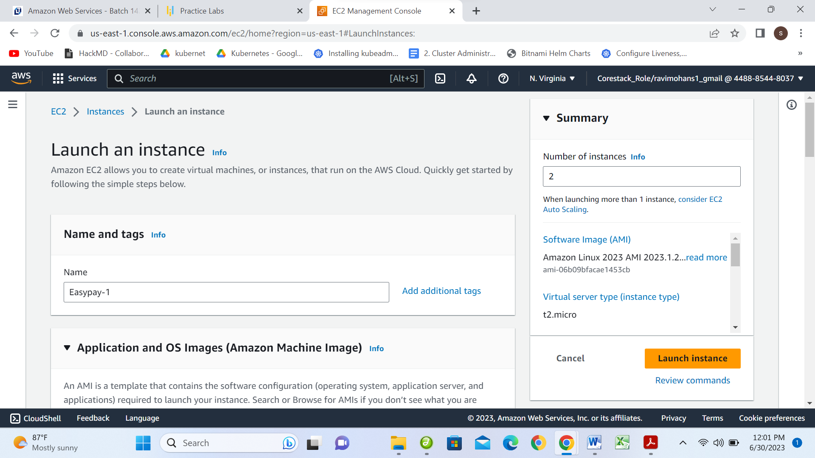

**Select AMI: Amazon Linux**

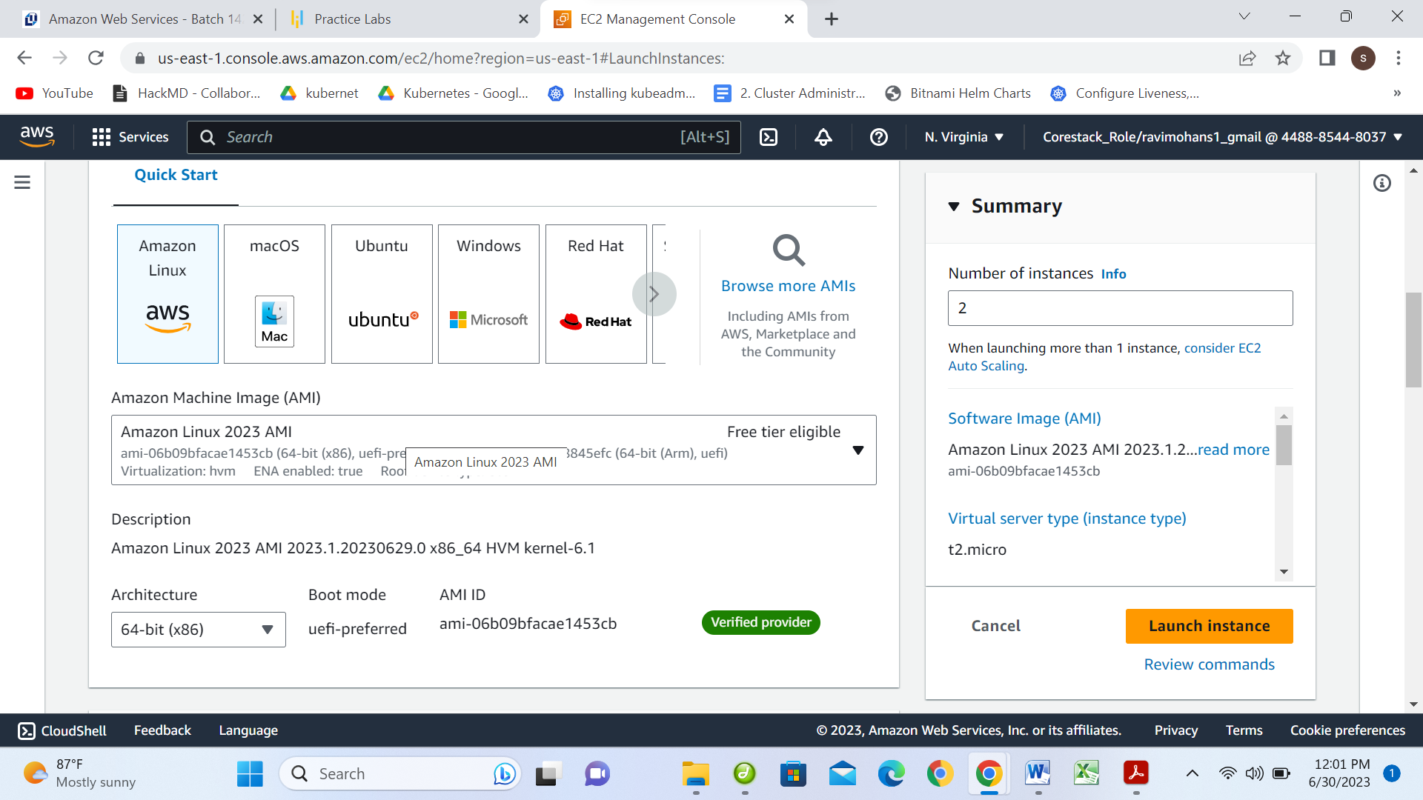

**Select Instance type: t2.macro**

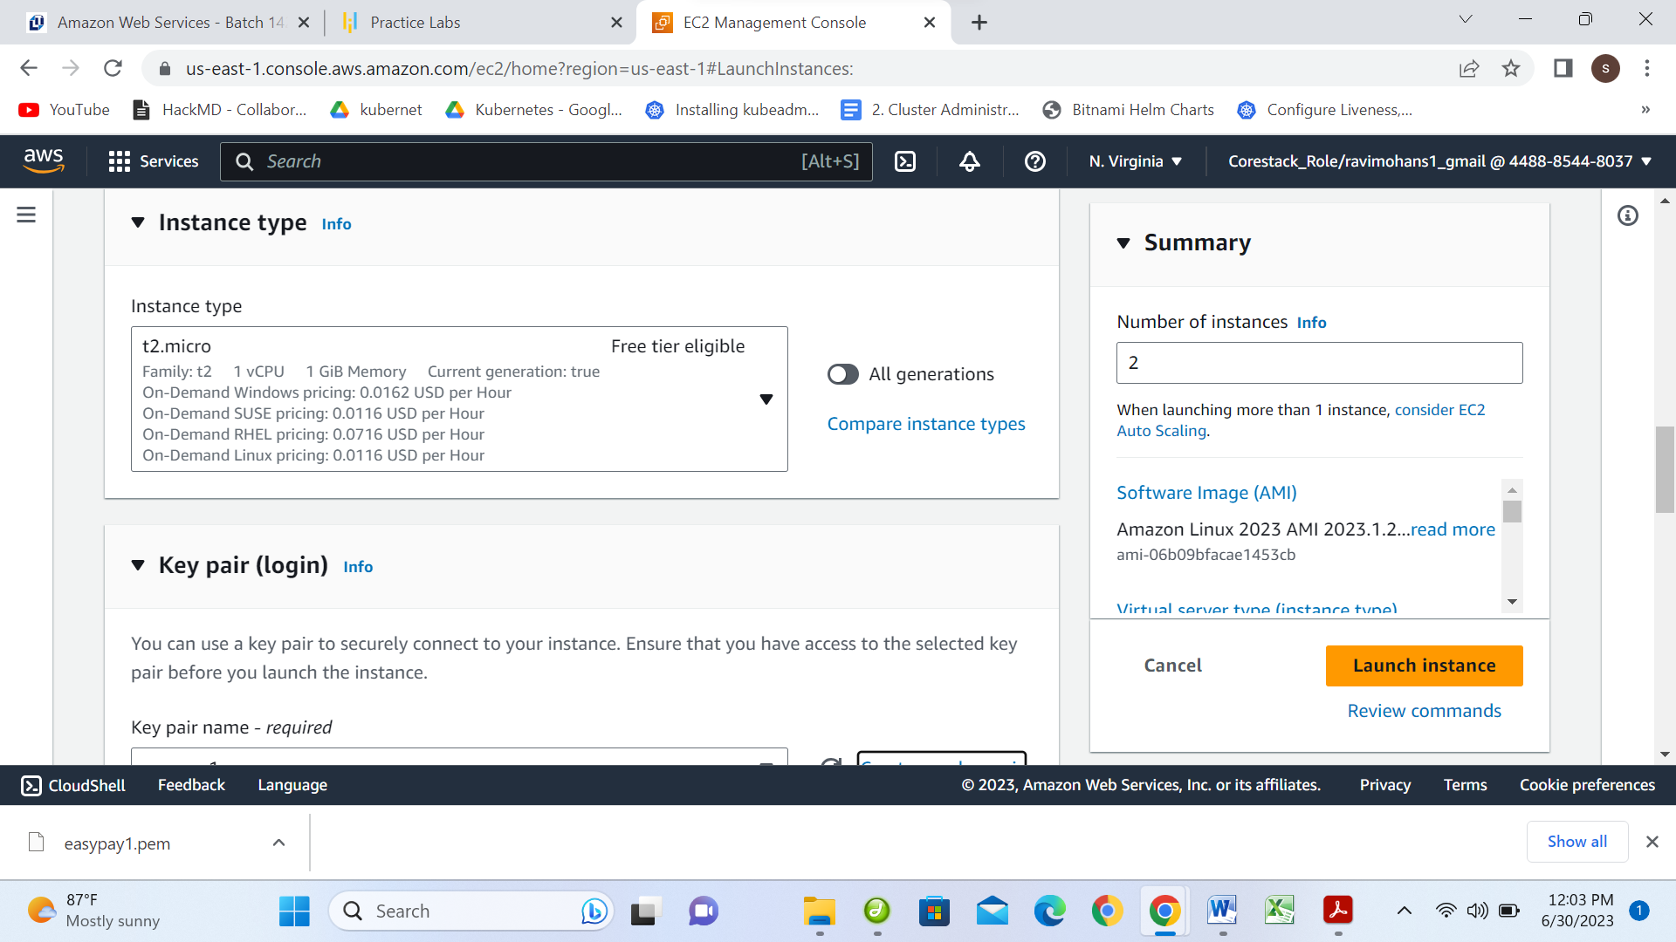

**Click on Create new key pair**

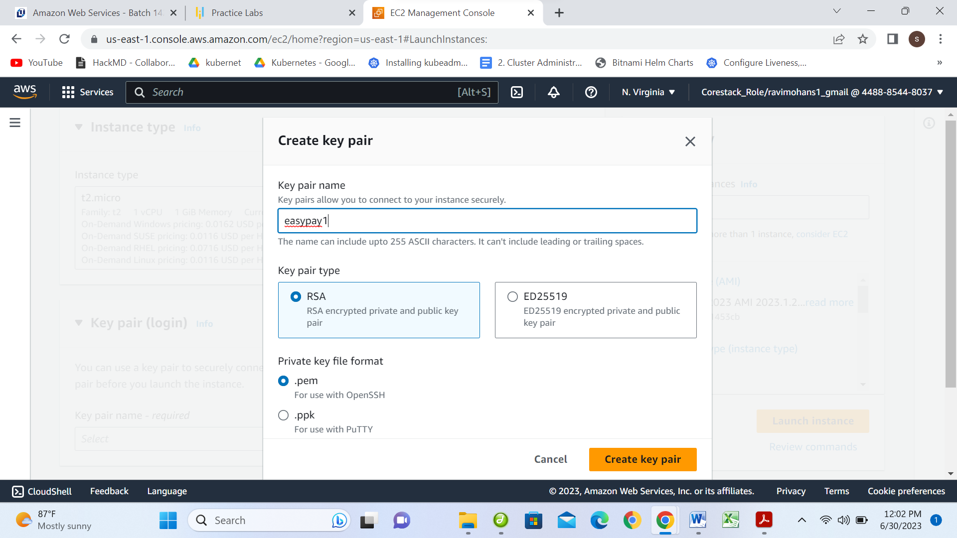



**Create Security Group**

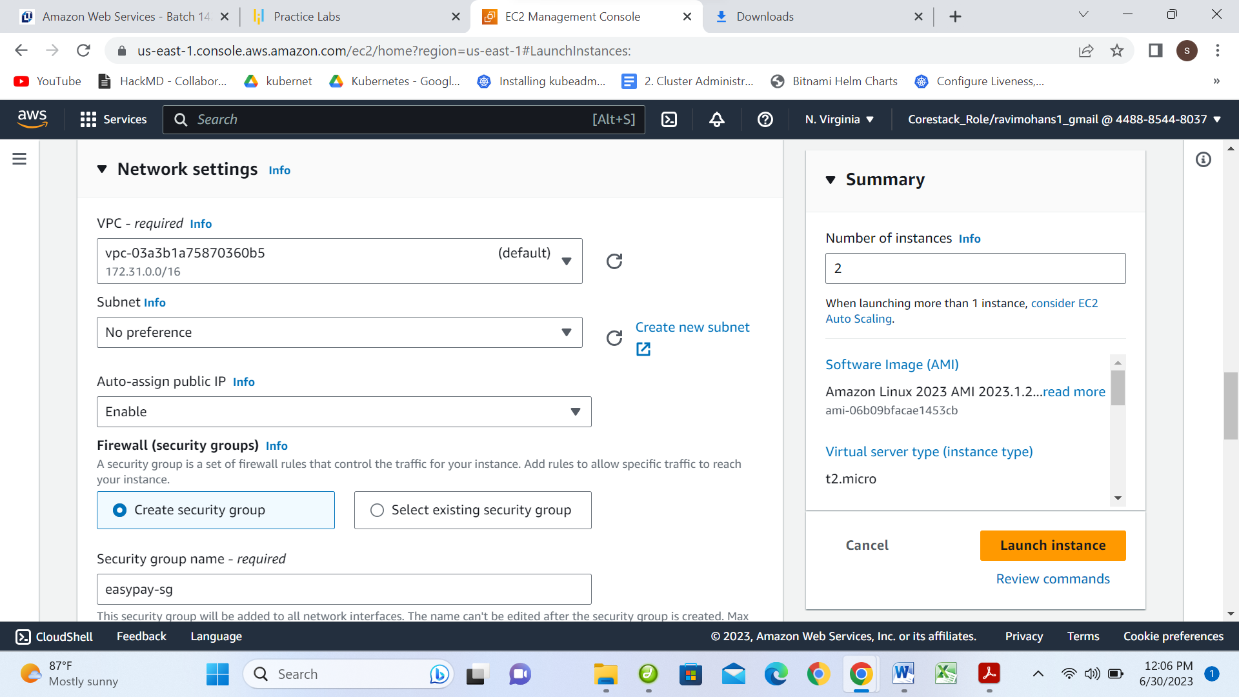

**Give Security group name & Enable SSH and HTTP**

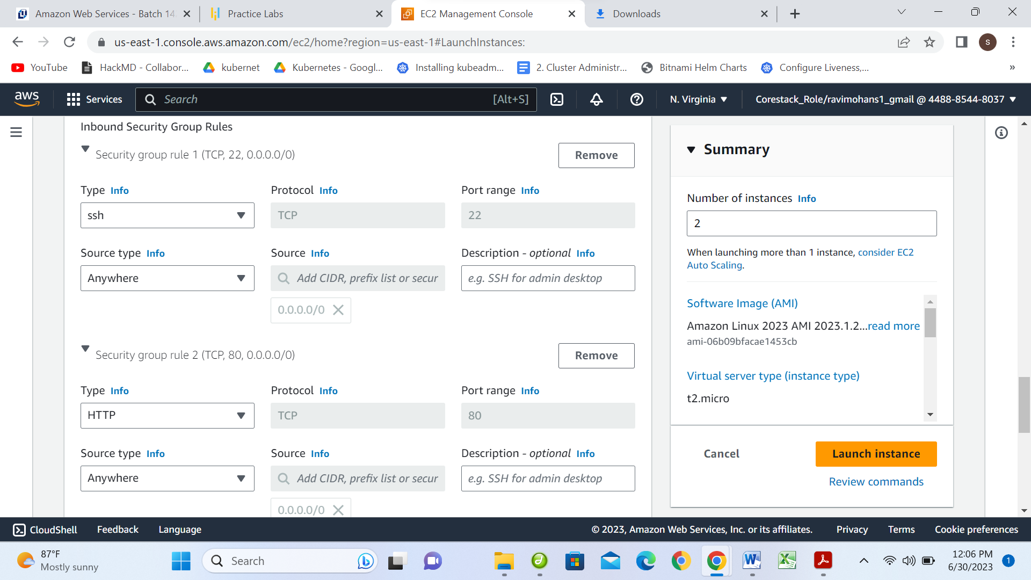

**Configure Storage**

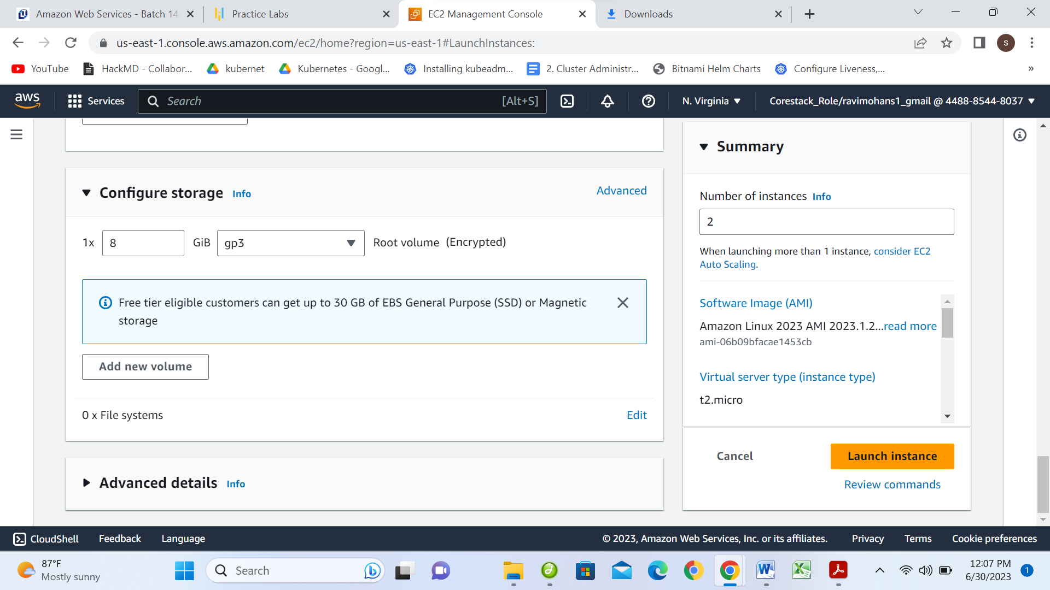

In advance setting, Give Bootstrap Script Code

#!/bin/bash

sudo su

yum update -y

yum install httpd -y

cd /var/www/html

echo "Load Balance-1" > index.html

service httpd start

chkconfig httpd on

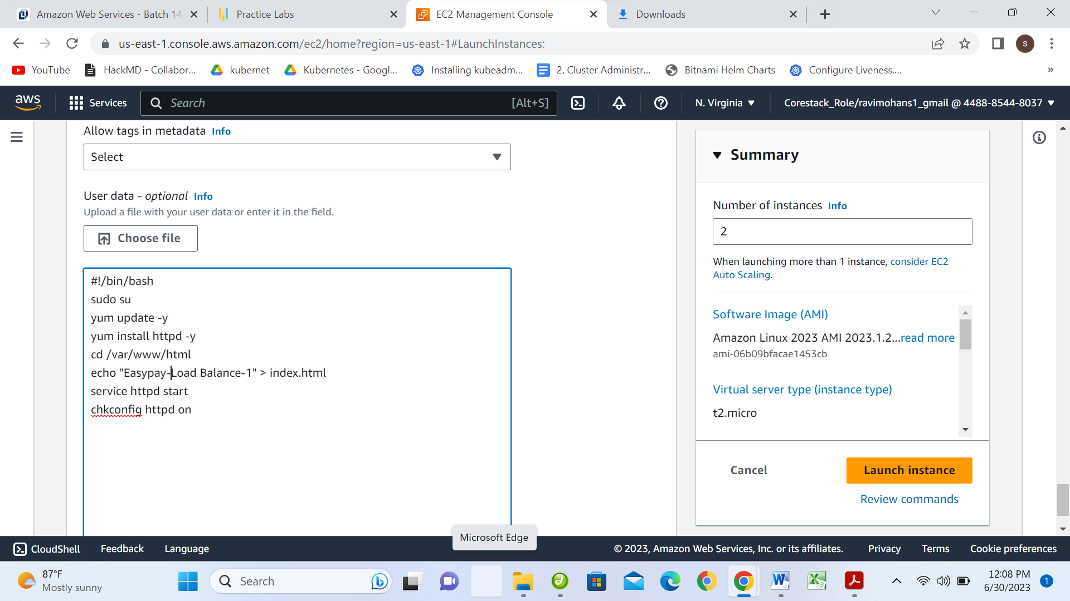

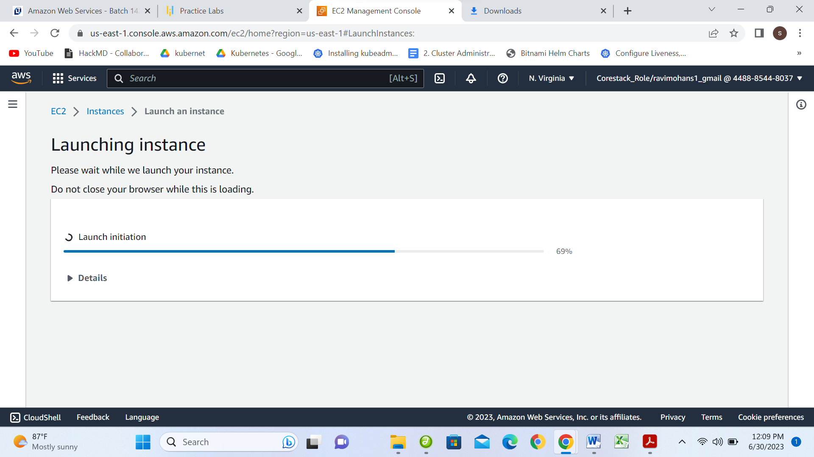

**Sucessfully Lanunc Instance**

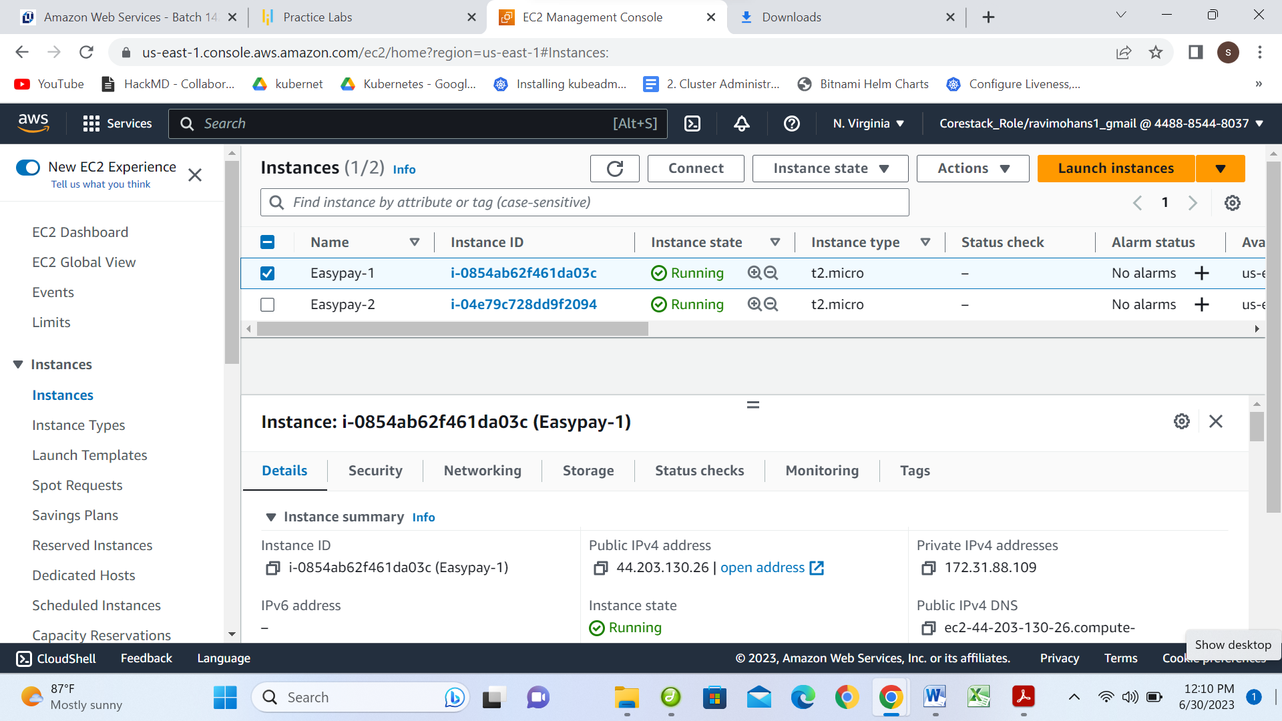

**Two instances created Easypay-1 & Easypay-2**

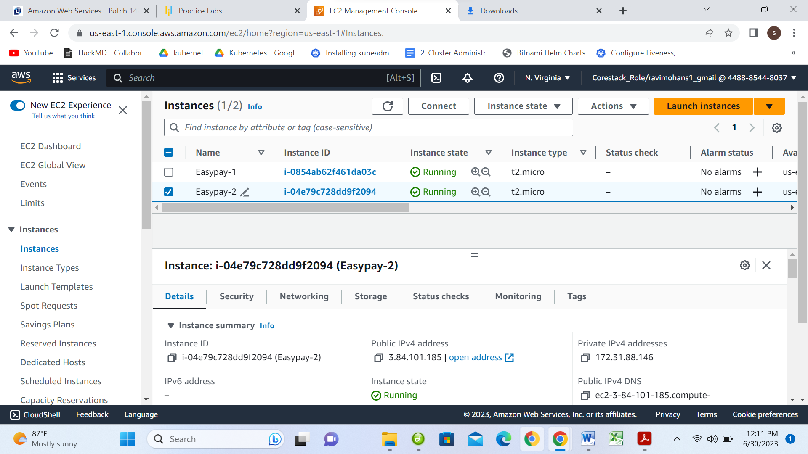

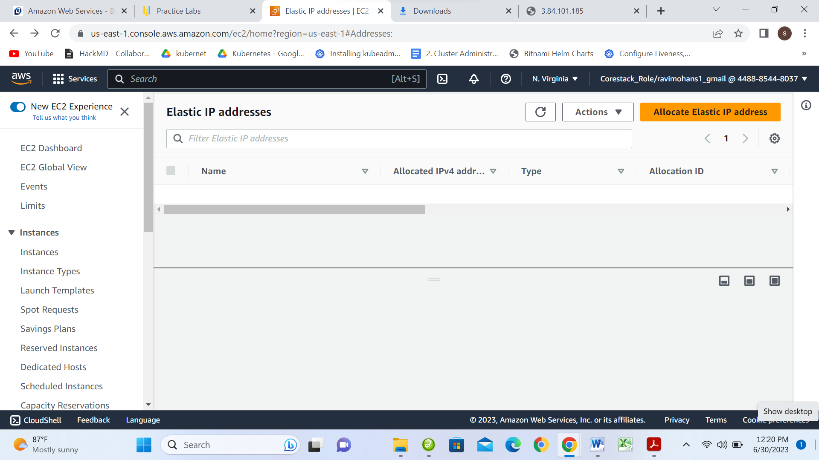

**To create Elastic IPs on 2 instances**

**Allocate Elastic IP address for 2 instances**

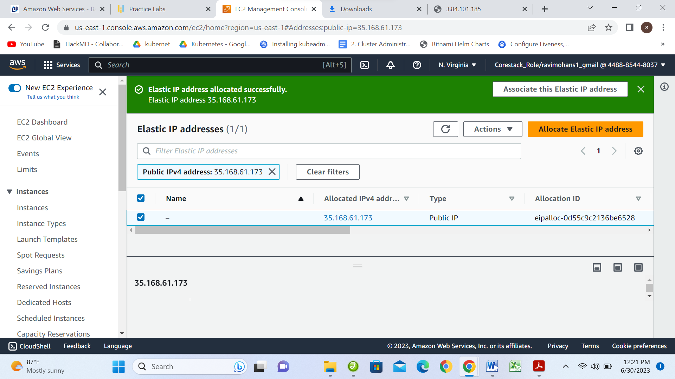

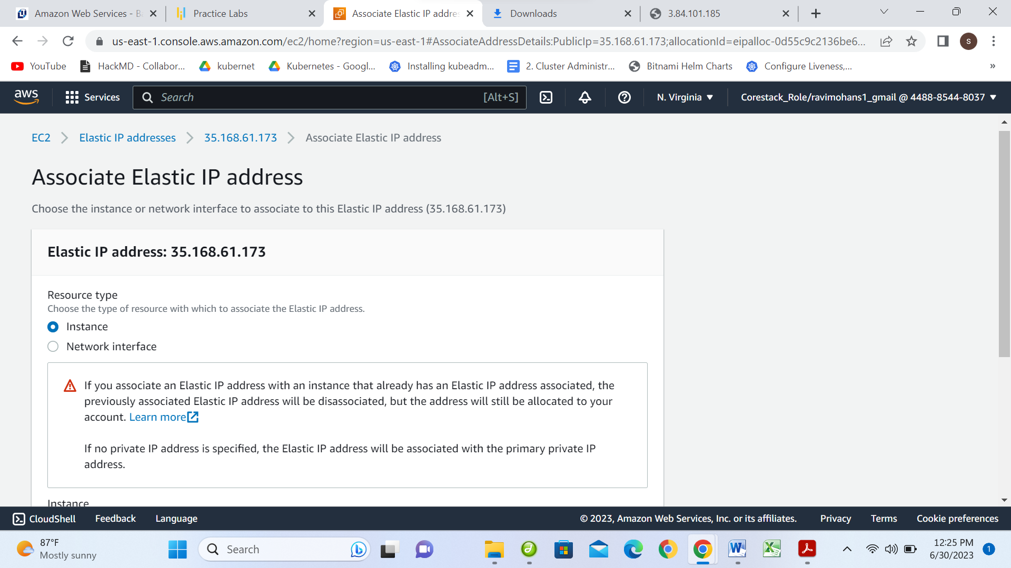

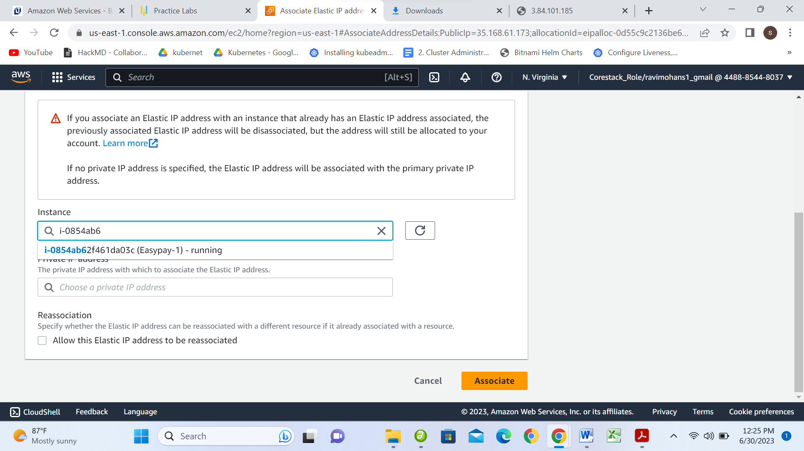

**Elestic Ip address to Easypay1 instance**

**35.168.61.173**

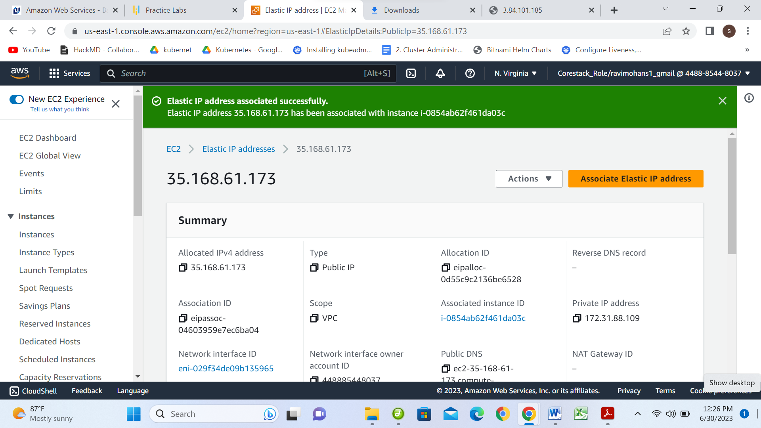

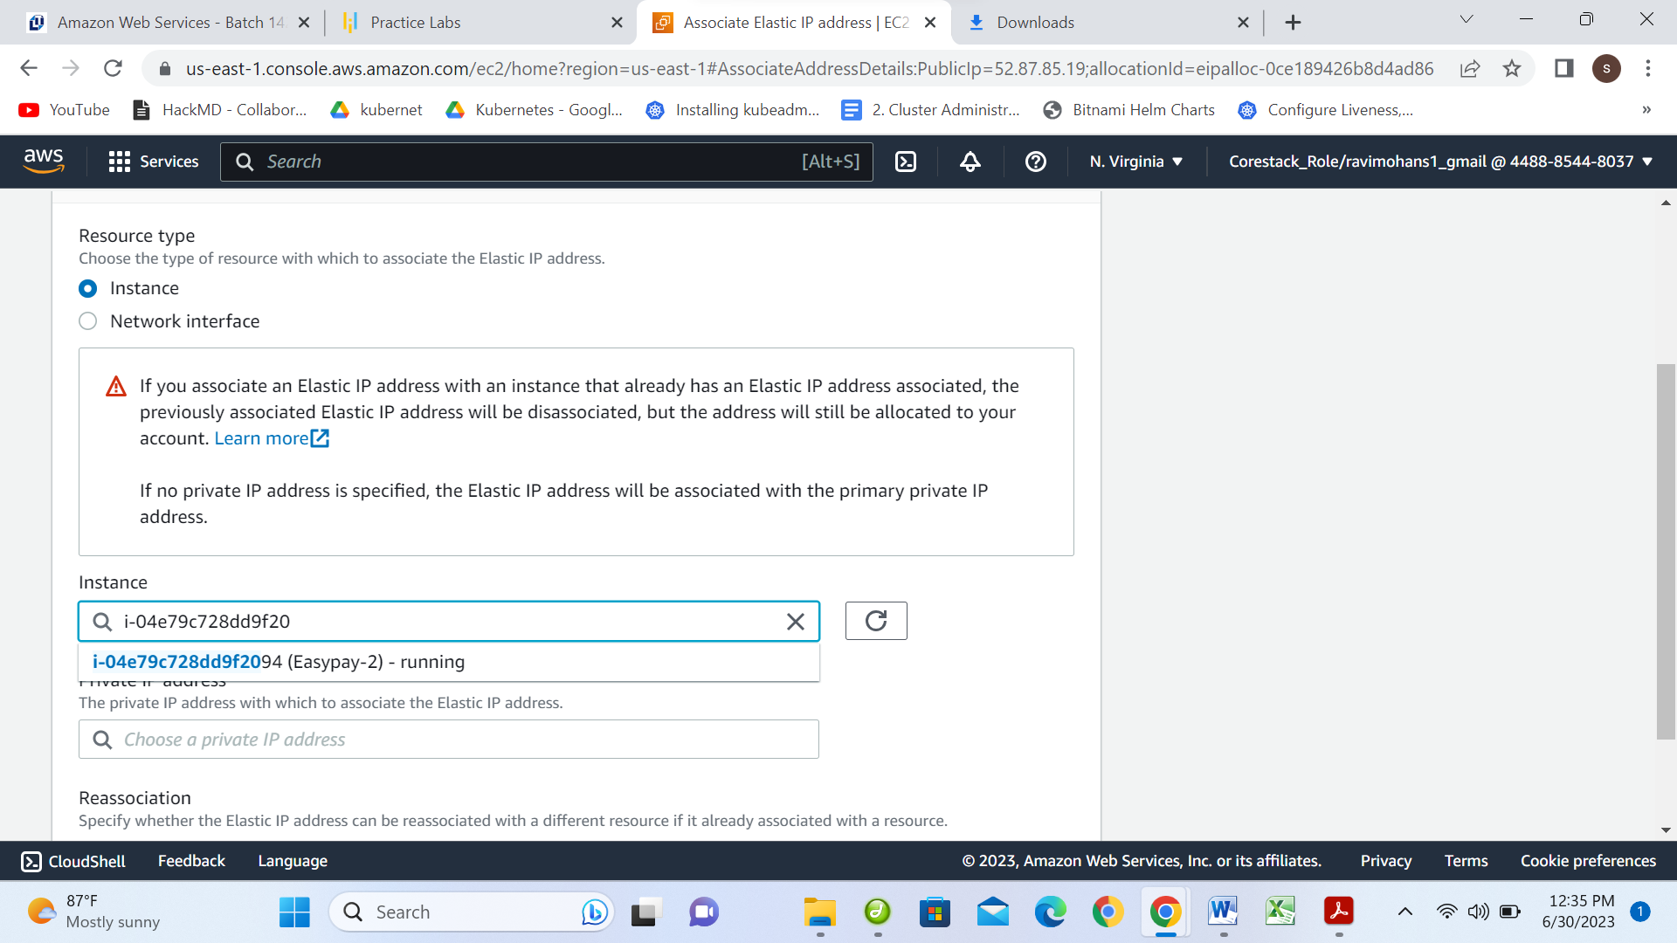

**Two Elastic IP addresses**

* 1. **Elastic IP: 35.168.61.173 for instance-1 Easypay-load balance1**
  2. **Elastic IP: 52.87.85.19 for instance-2 Easypay-load balance2**

**To create a Application Load Balancer**

**First create target group**

**Configure your target group**

* + In the navigation pane, under **Load Balancing**, choose **Target Groups**.
  + Choose **Create target group**.
  + Under **Basic configuration**, keep the **Target type** as instance.
  + For **Target group name**, enter a name for the new target group.
  + Keep the default protocol (**HTTP**) and port (**80**).
  + Select the **VPC** containing your instances. Keep the protocol version as **HTTP1**.
  + For **Health checks**, keep the default settings.
  + Choose Next.
  + On the **Register targets** page, complete the following steps. This is an optional step for creating the load balancer. However, you must register this target if you want to test your load balancer and ensure that it is routing traffic to this target.
  + For **Available instances**, select one or more instances.
  + Keep the default port 80, and choose **Include as pending below**.
  + Choose **Create target group**.

**Create target group: Easypay1 & Easypay2**

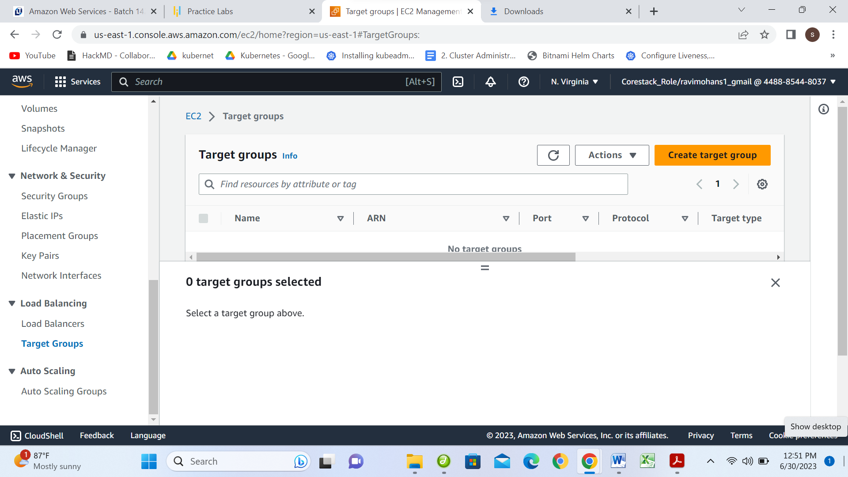

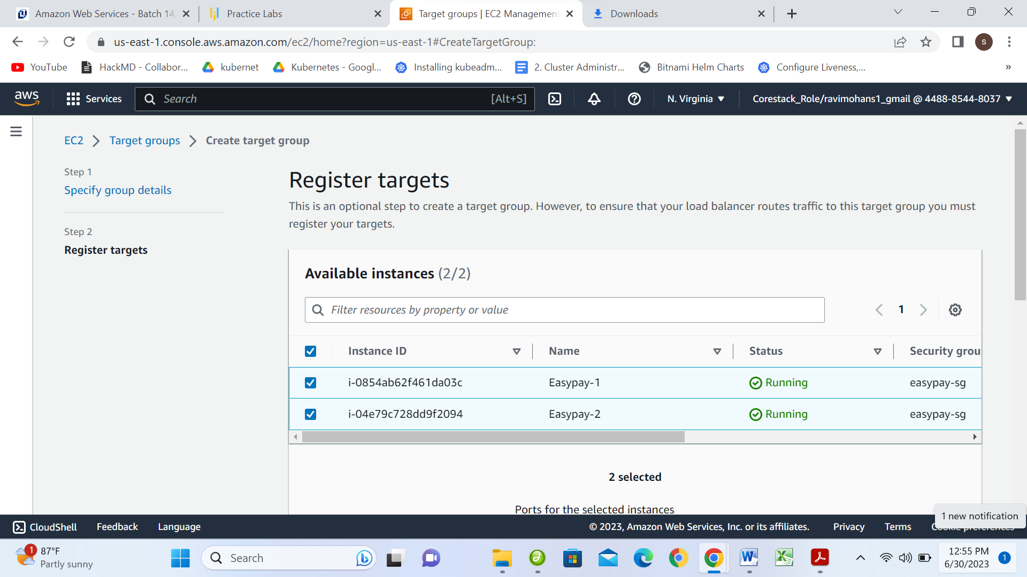

Keep the default port 80, and choose **Include as pending below**

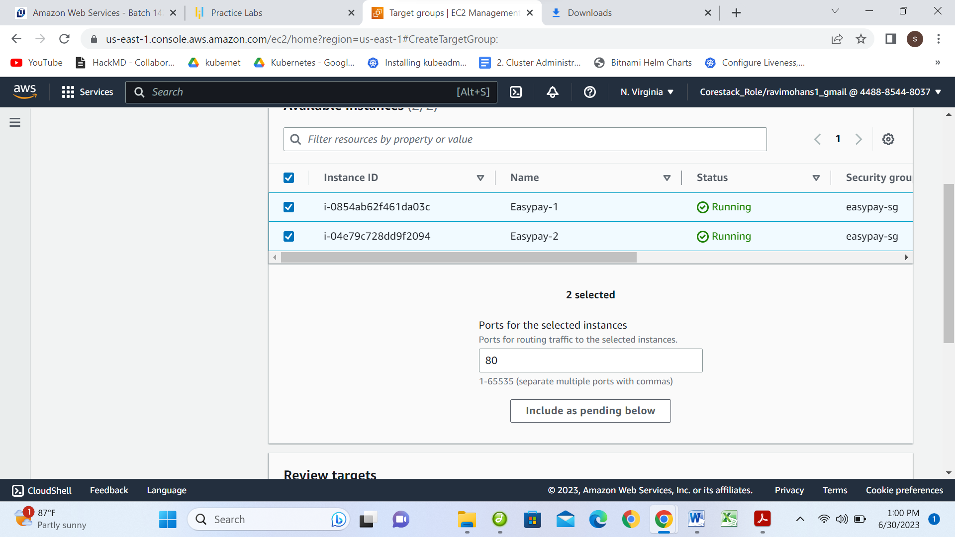

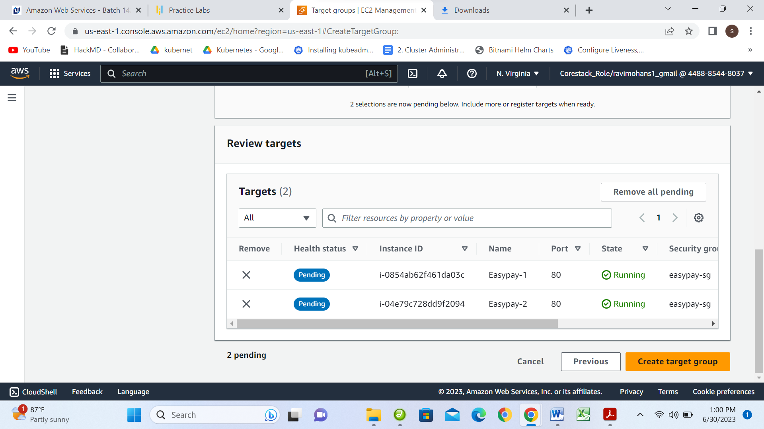

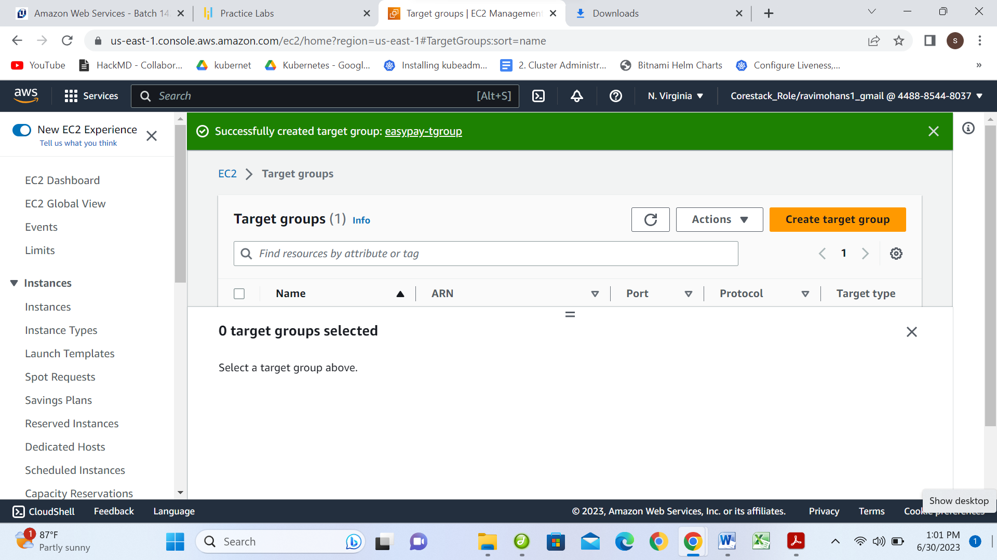

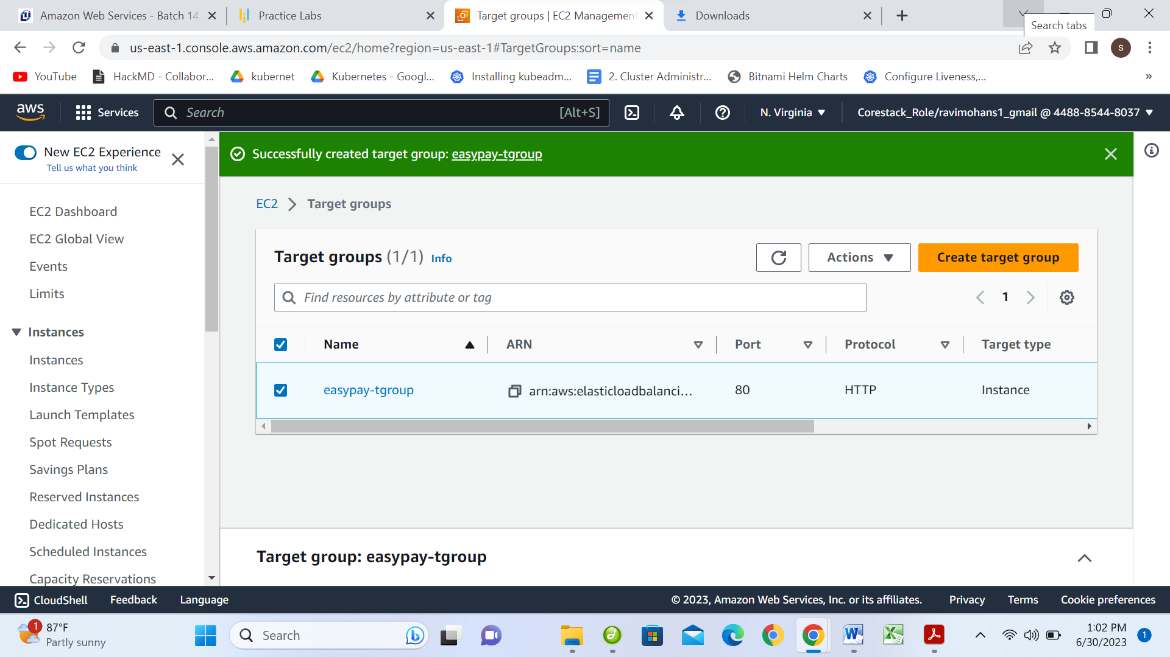

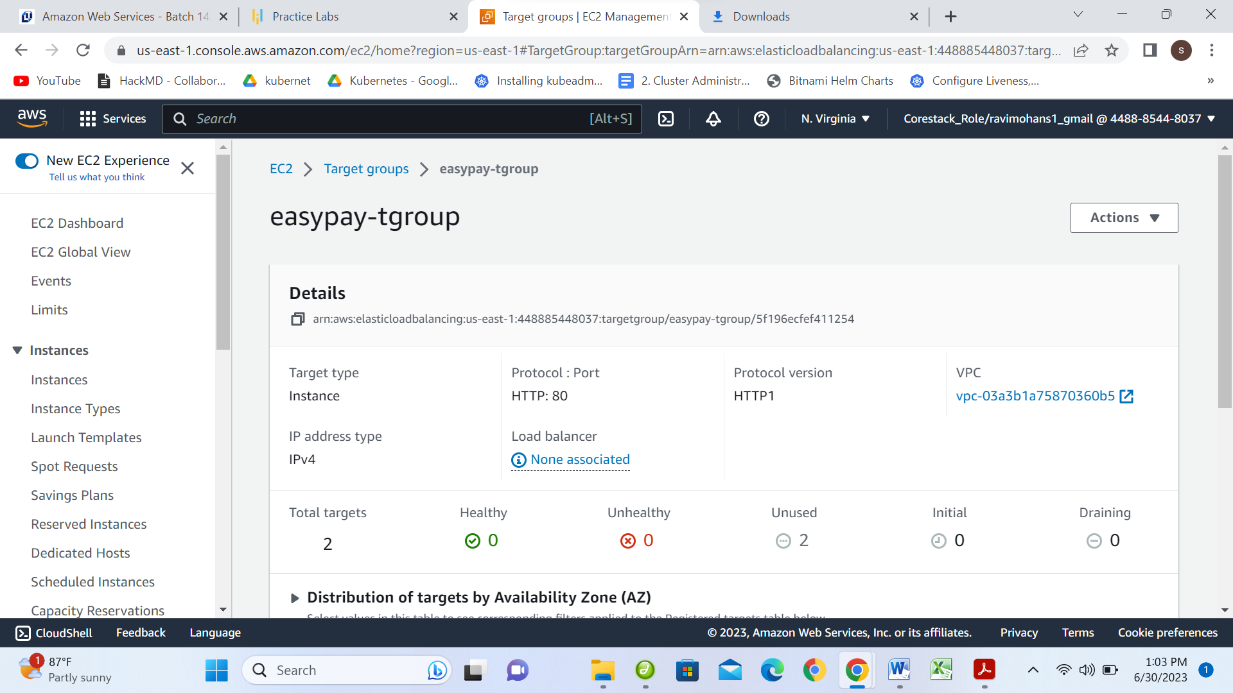

**To create a Application Load Balancer**

**Open the Amazon EC2 console at https://console.aws.amazon.com/ec2/.**

**On the navigation bar, choose a Region for your load balancer. Be sure to choose the same Region that you used for your EC2 instances.**

**In the navigation pane, under Load Balancing, choose Load Balancers.**

**Choose Create Load Balancer.**

**For Application Load Balancer, choose Create**

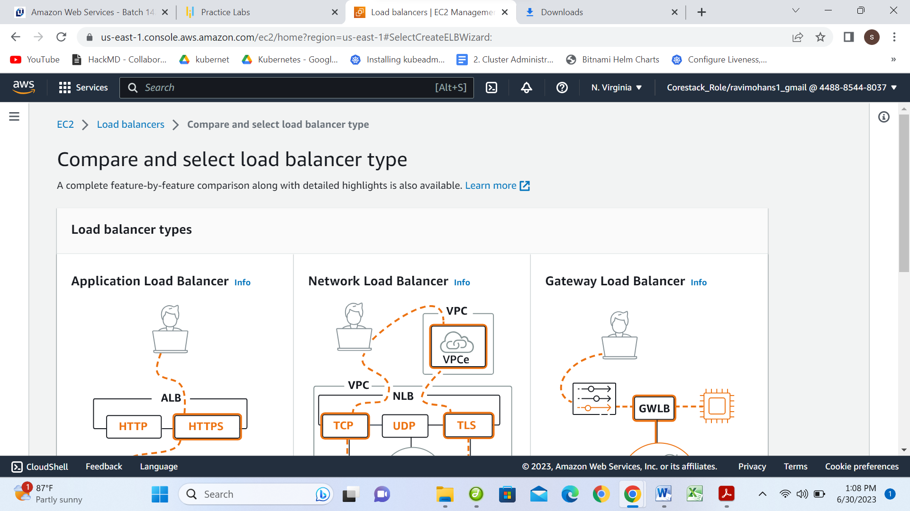

**Create Load Balancer easypay-loadbalancer**

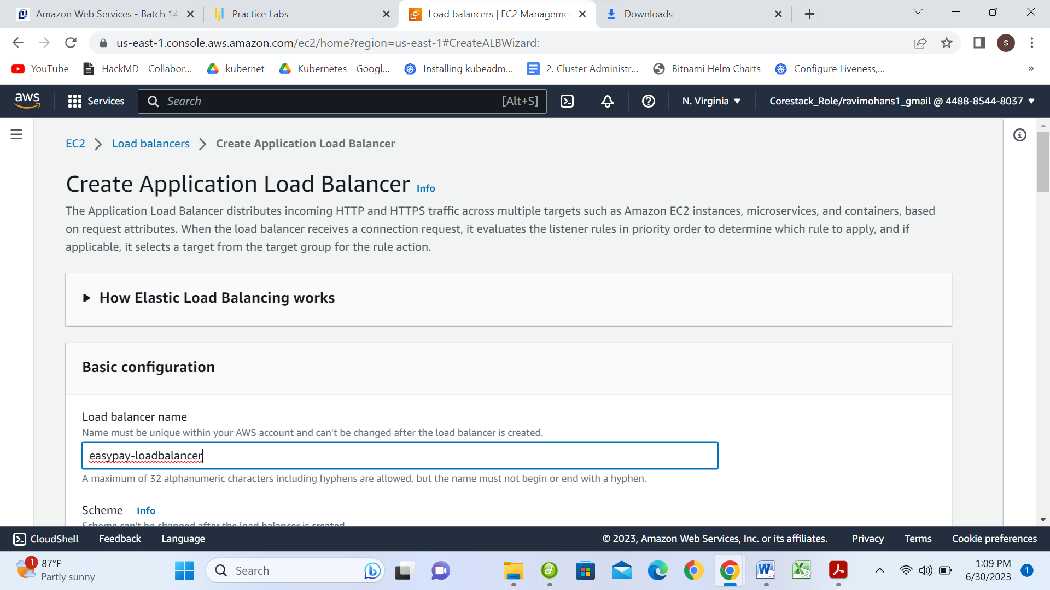

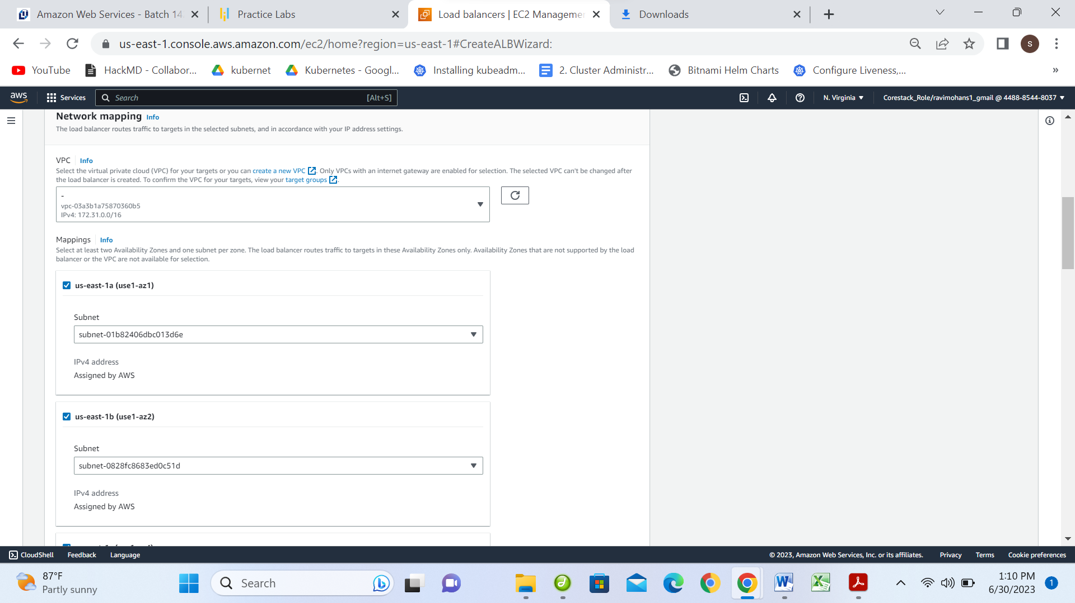

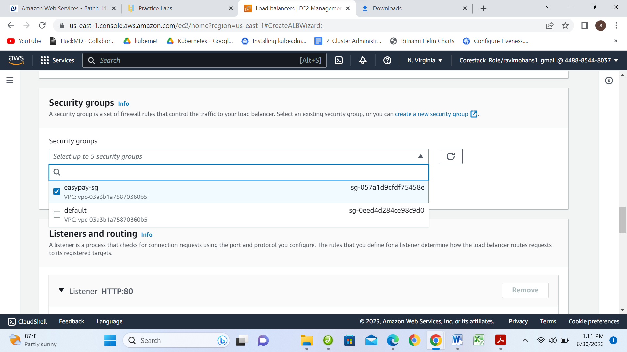

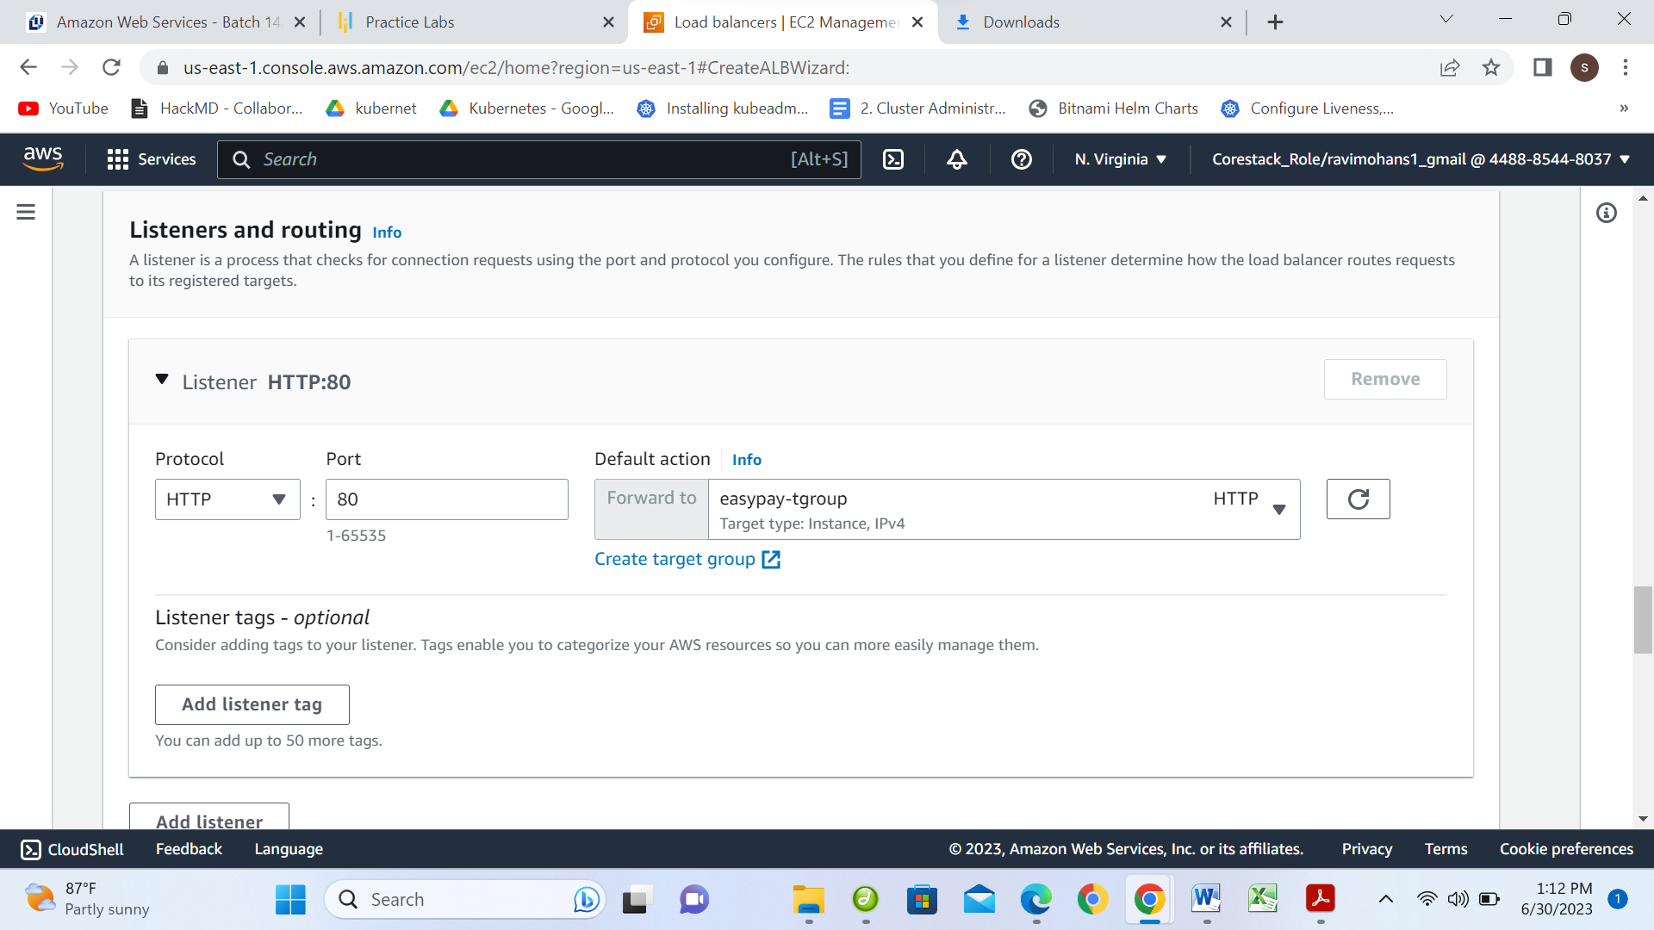

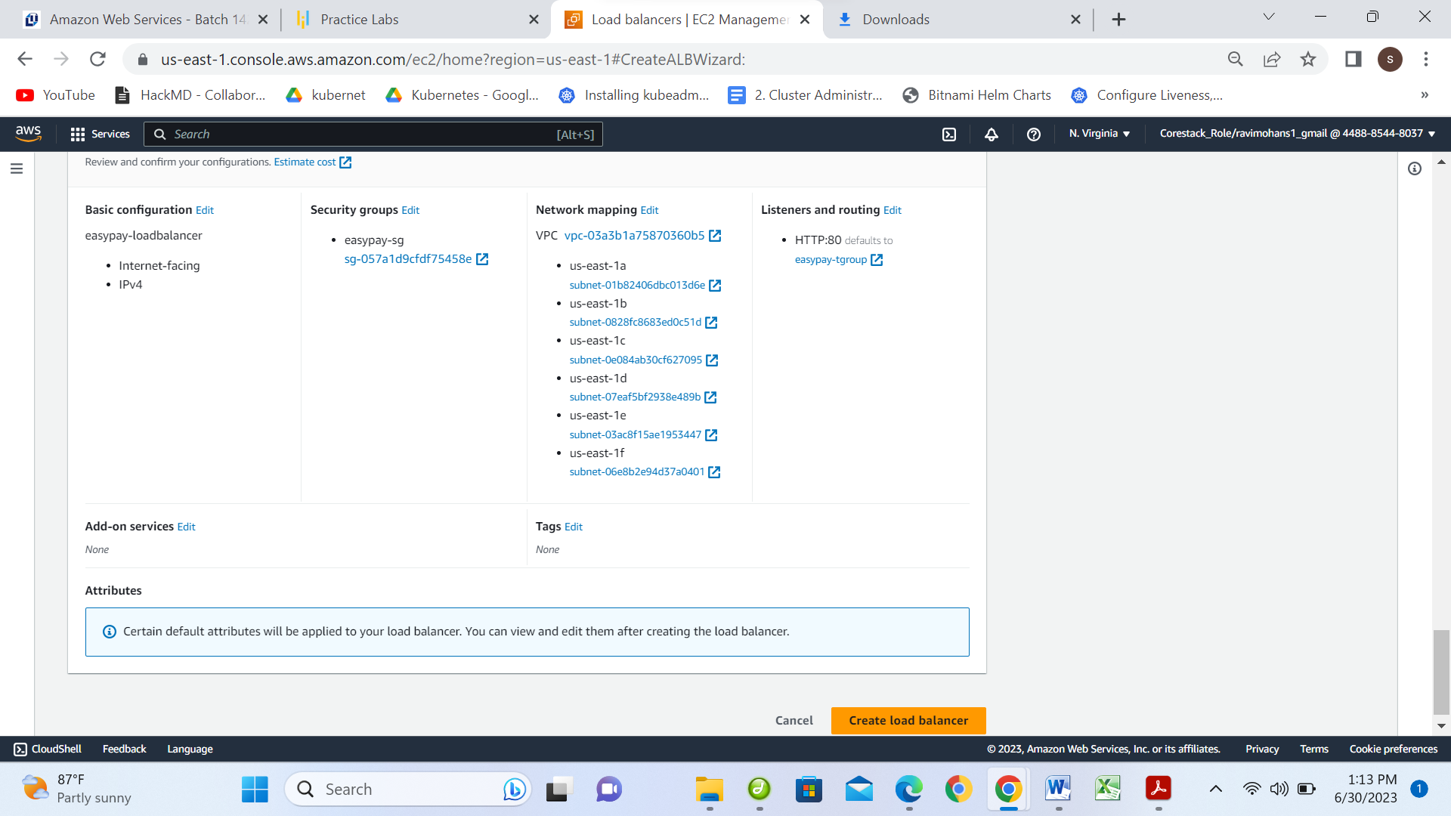

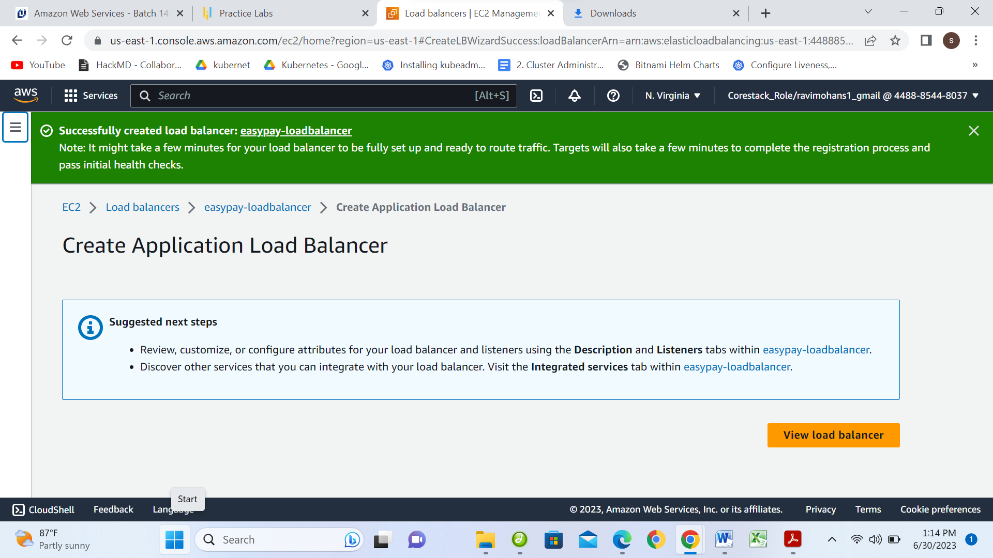

**Copy public IP and check in the Browser**

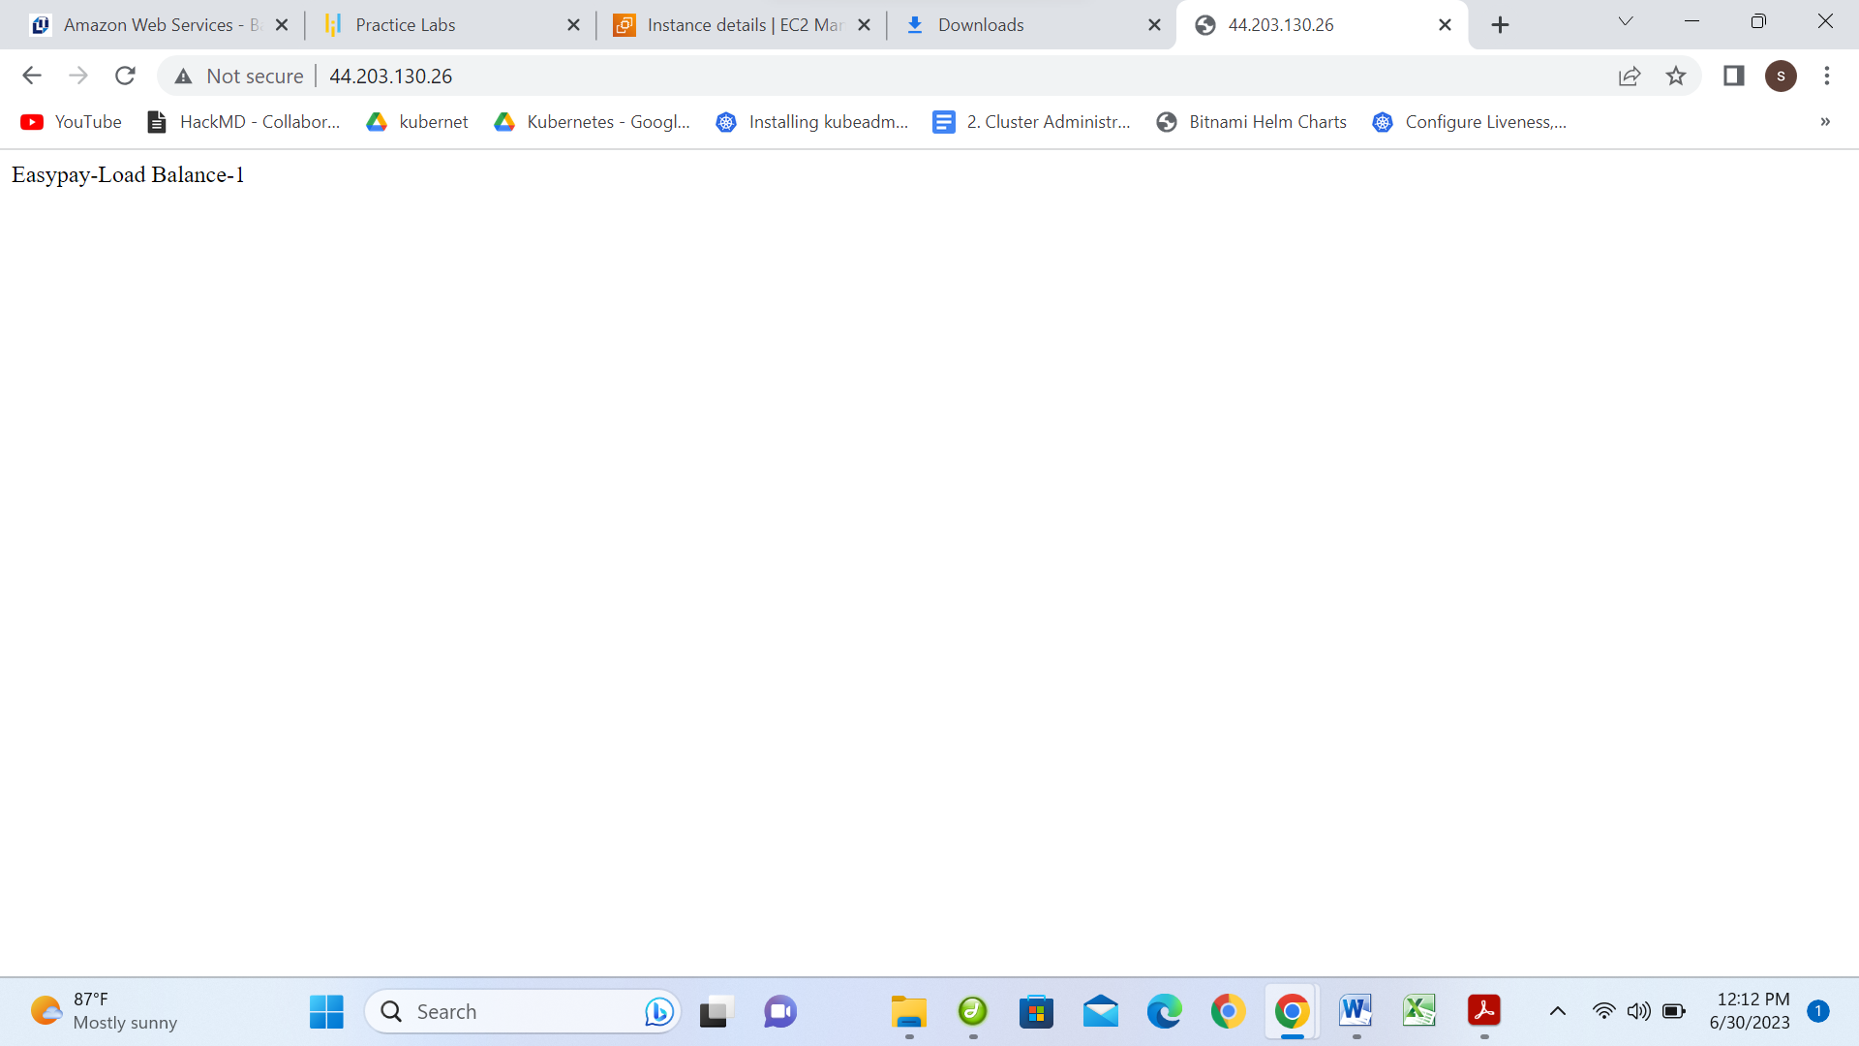

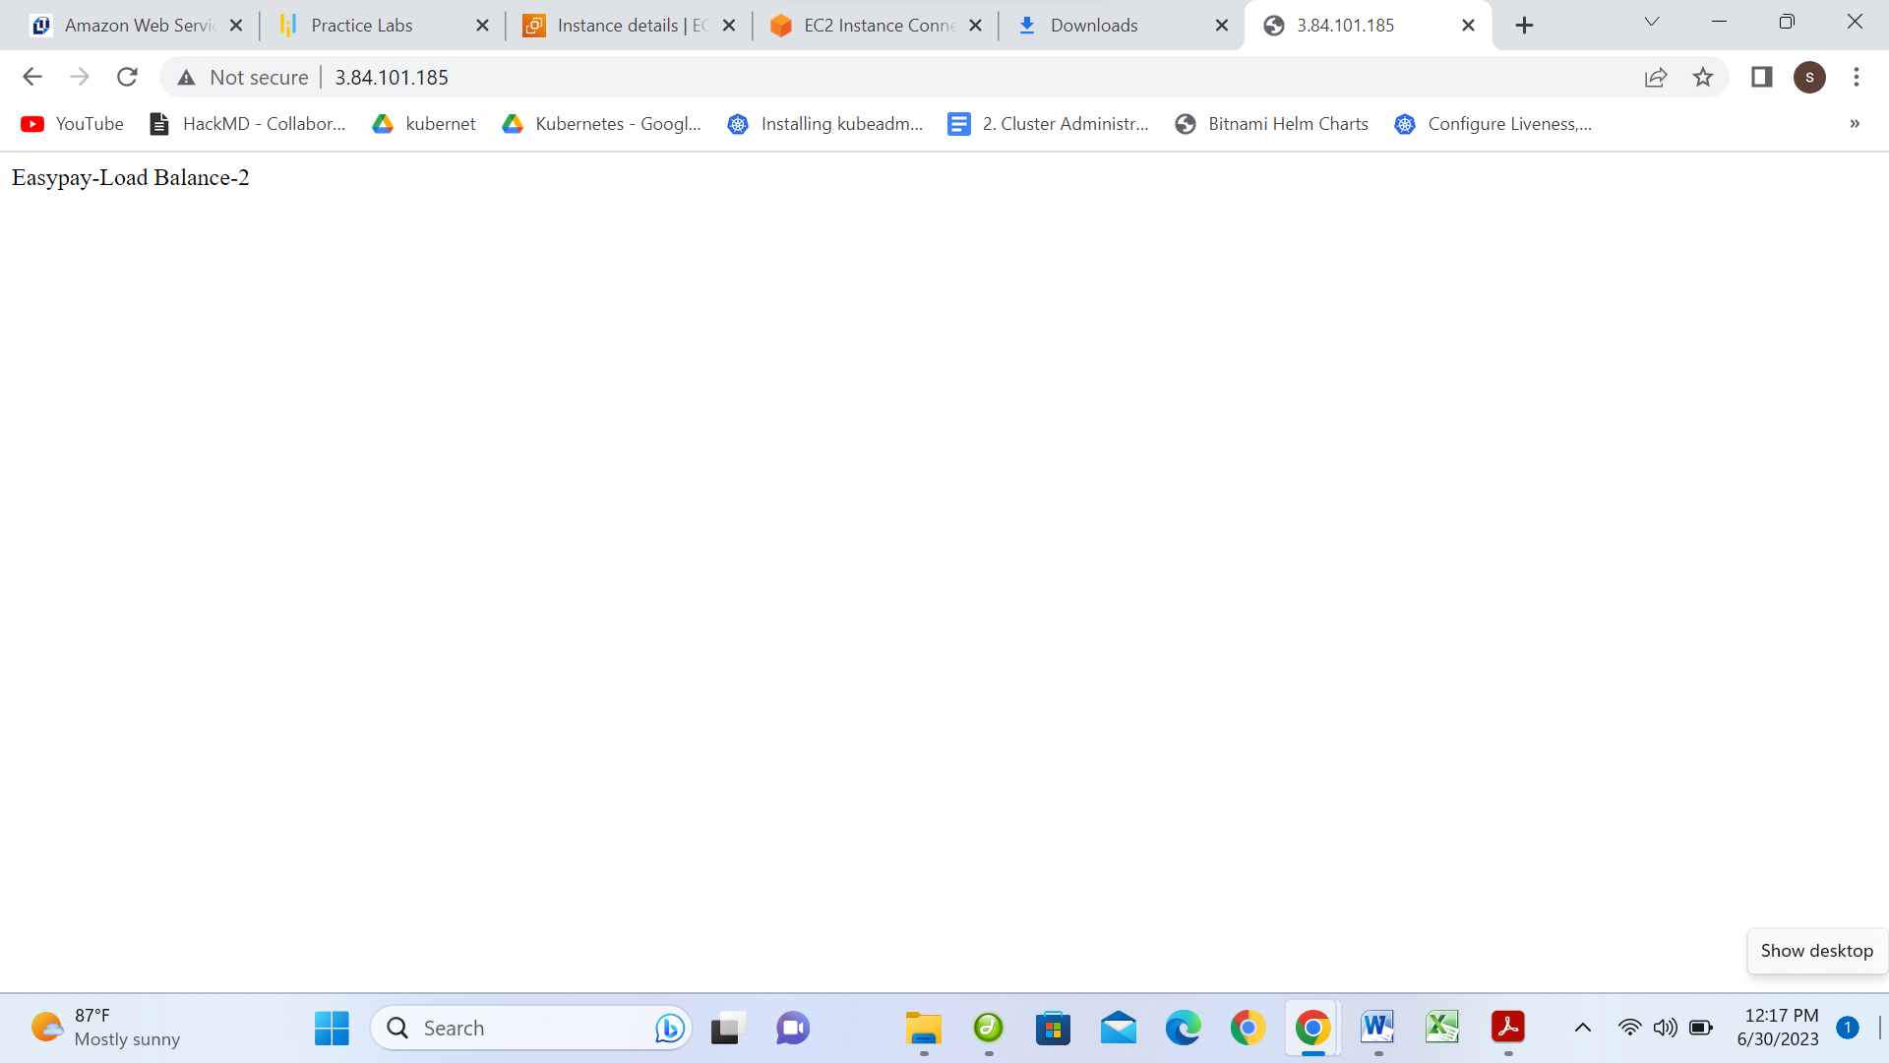

***

**2. To automate the provisioning of an EC2 instance creation using Ansible (Automation)**

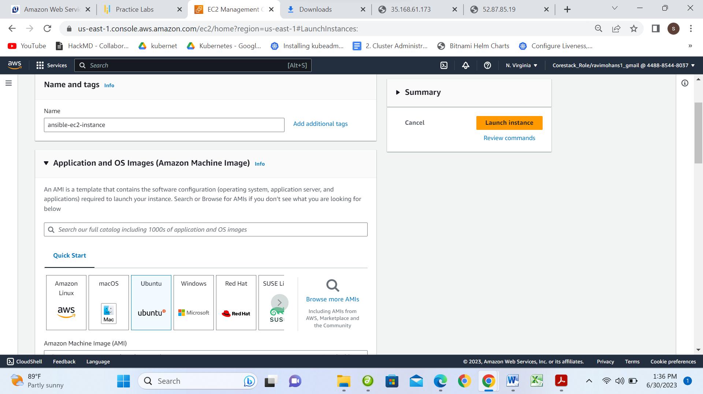

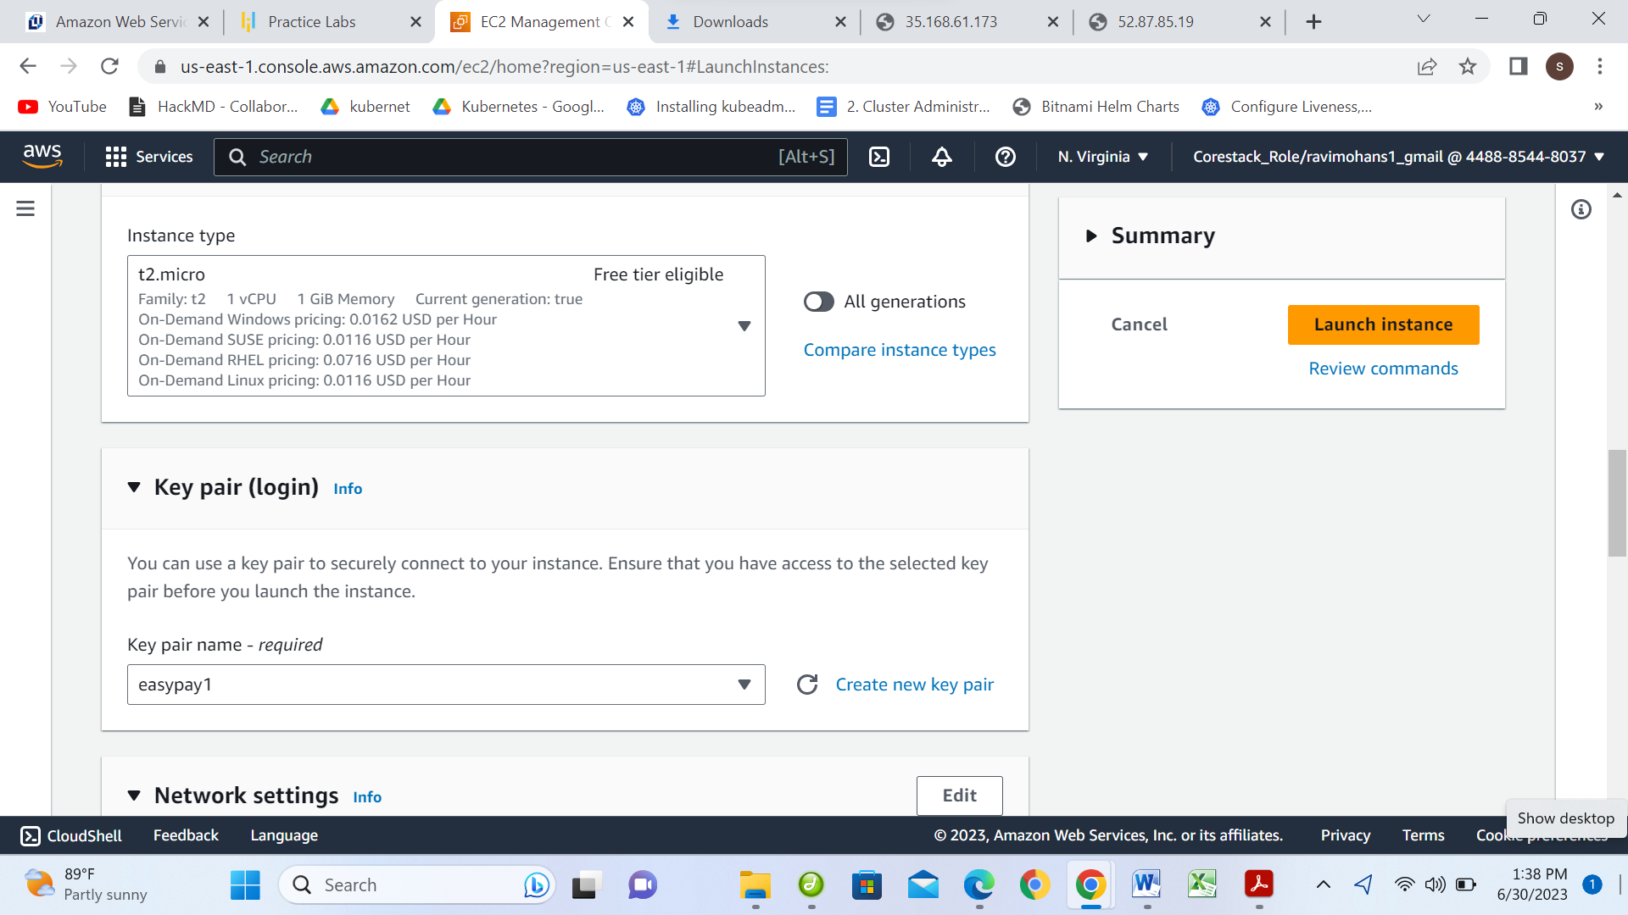

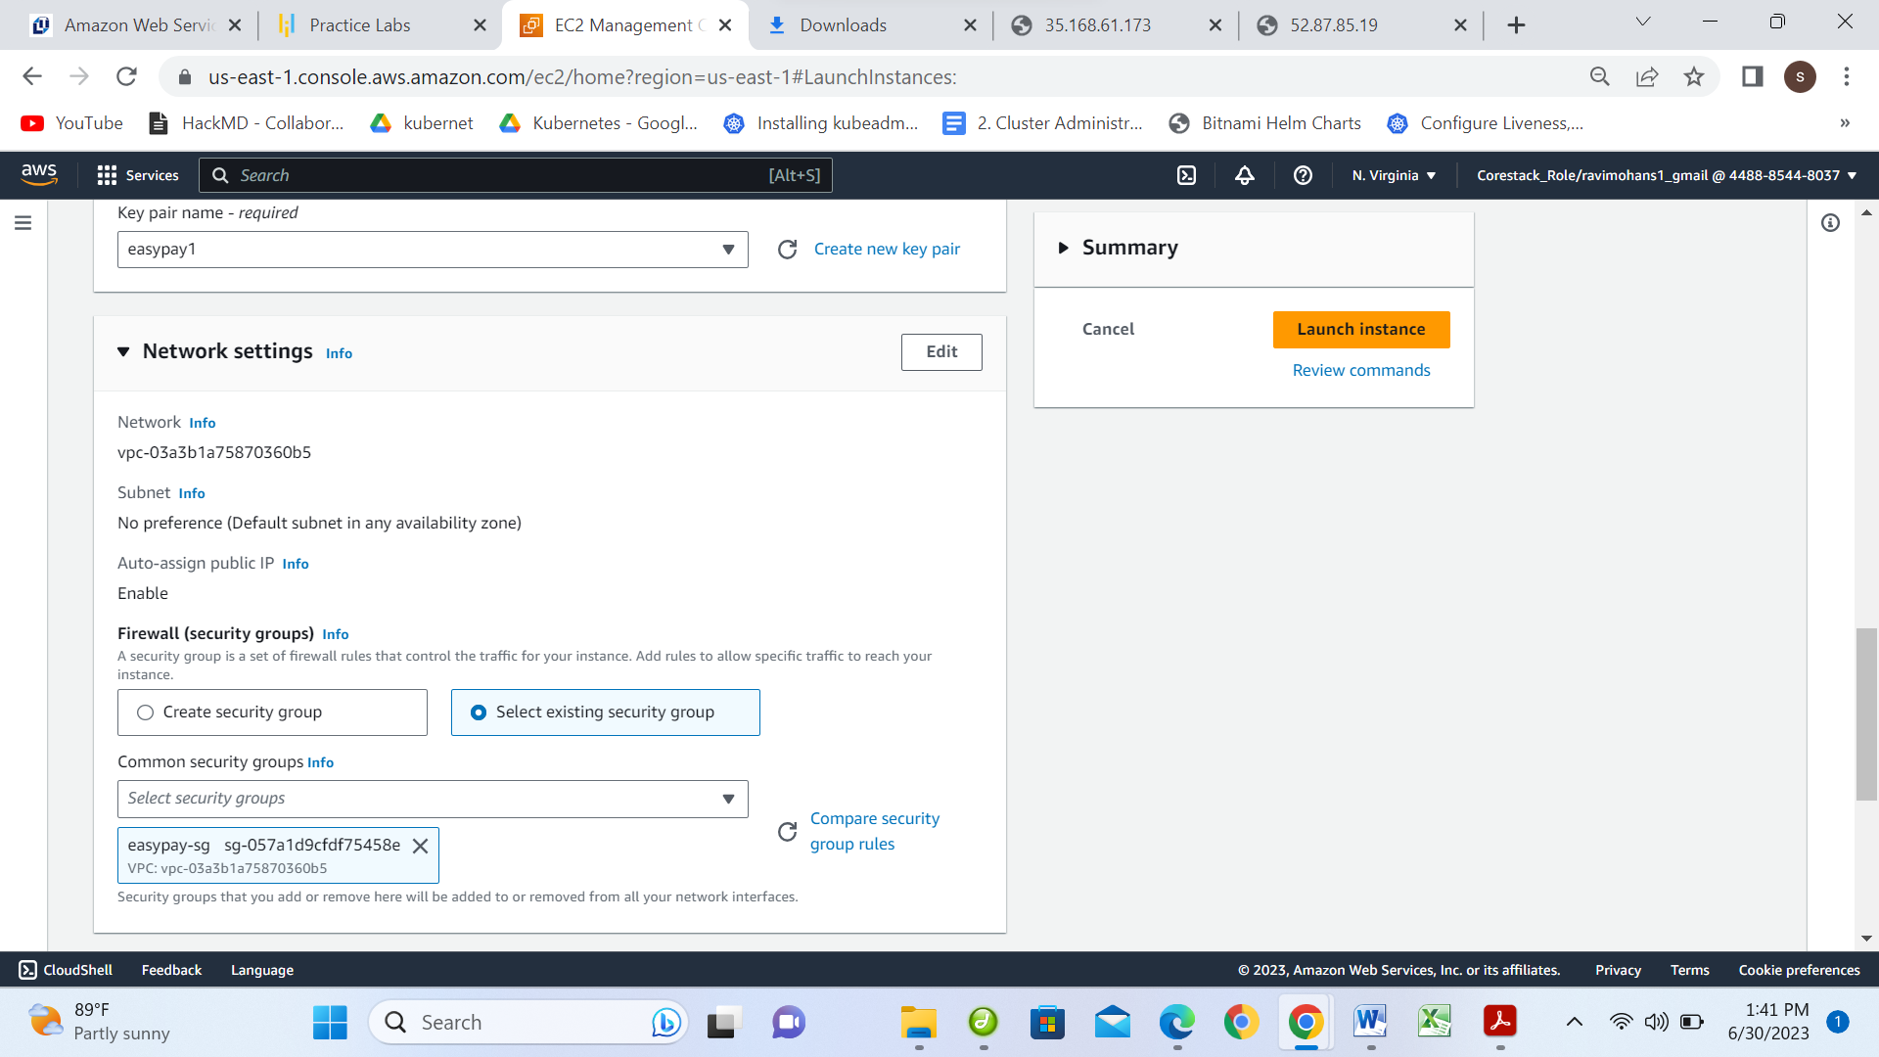

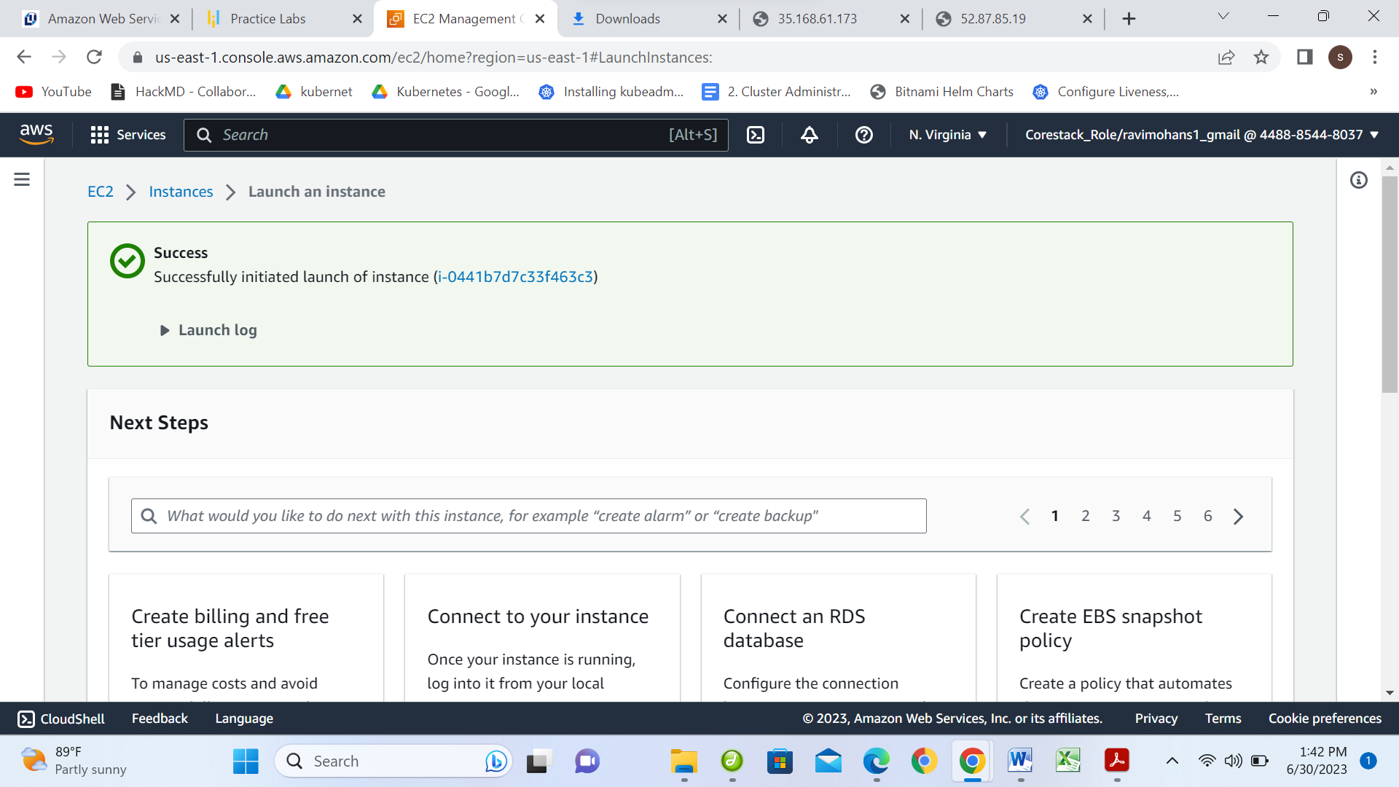

**$ sudo apt-get update**

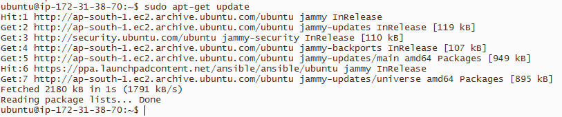

**$sudo apt-get install python3-pip**

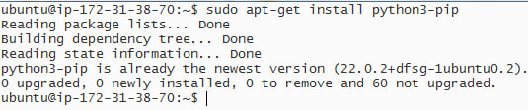

**$sudo pip3 install boto boto3**

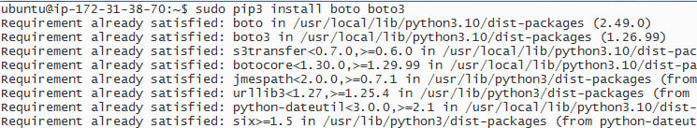

**$sudo apt-get install ansible**

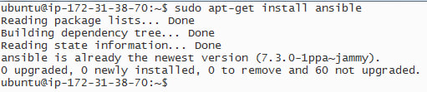

**$ansible –version**

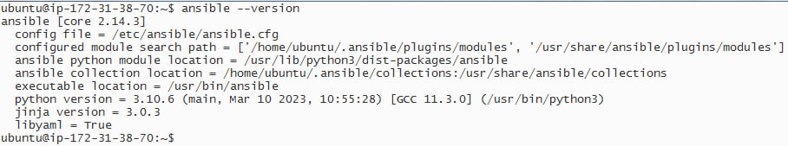

**Step:2**

**example inventory file in YAML format**

**$vim /etc/ansible/hosts**

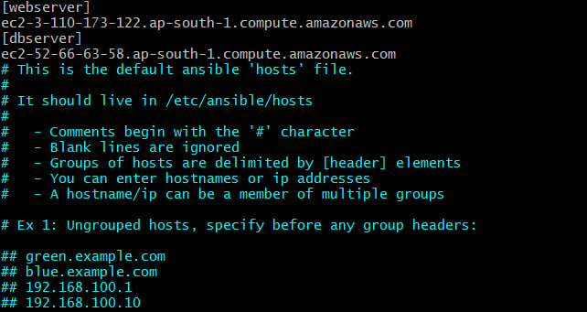

**Create IAM role and attach to instance**

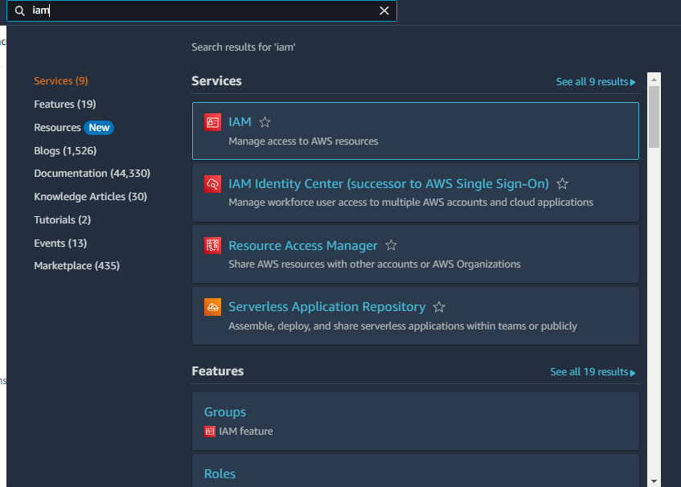

**Click on Creae role**

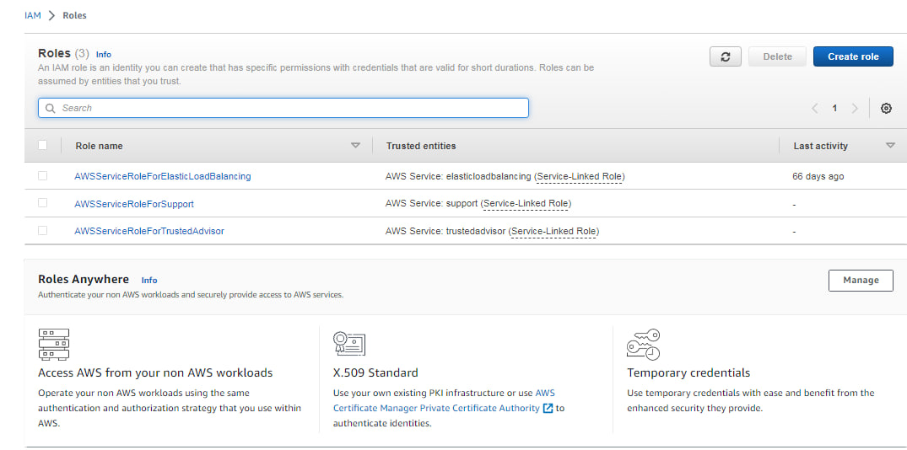

**Select EC2 and press Next**

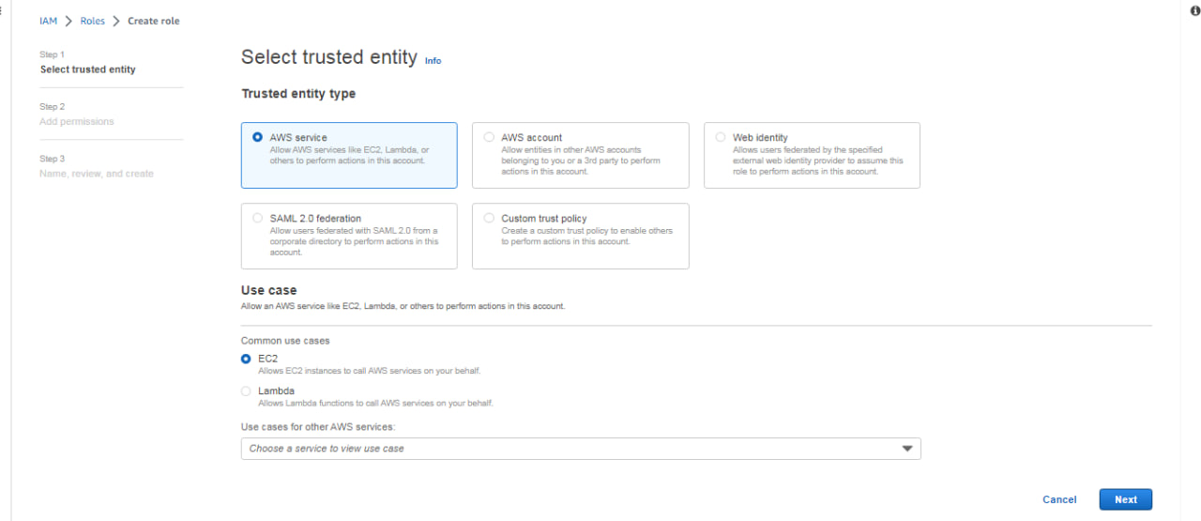

**Select AmazonEc2FullAccess**

**Click Next**

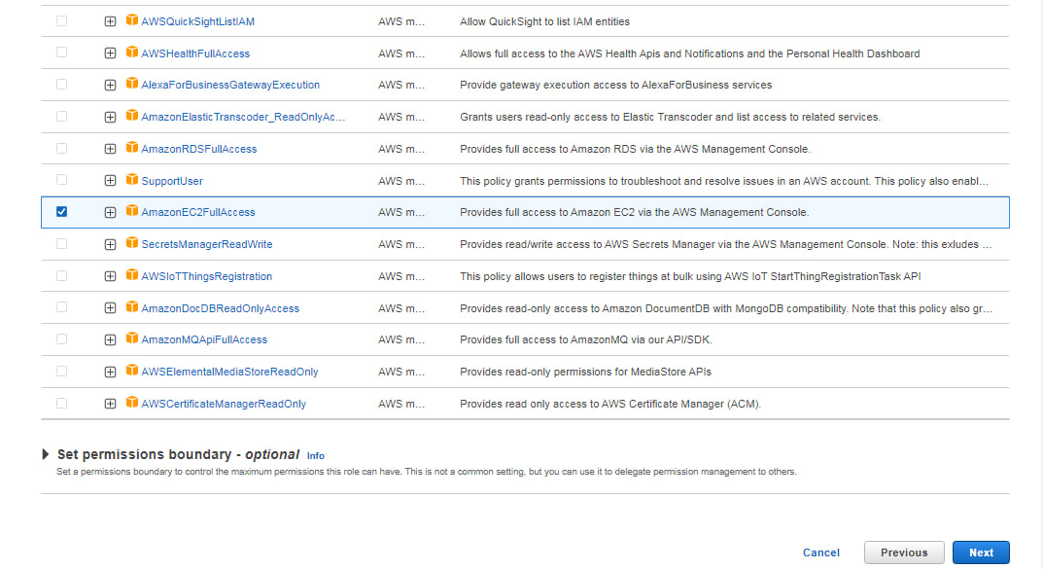

**Give Name: ansible_role**

**Click on Create**

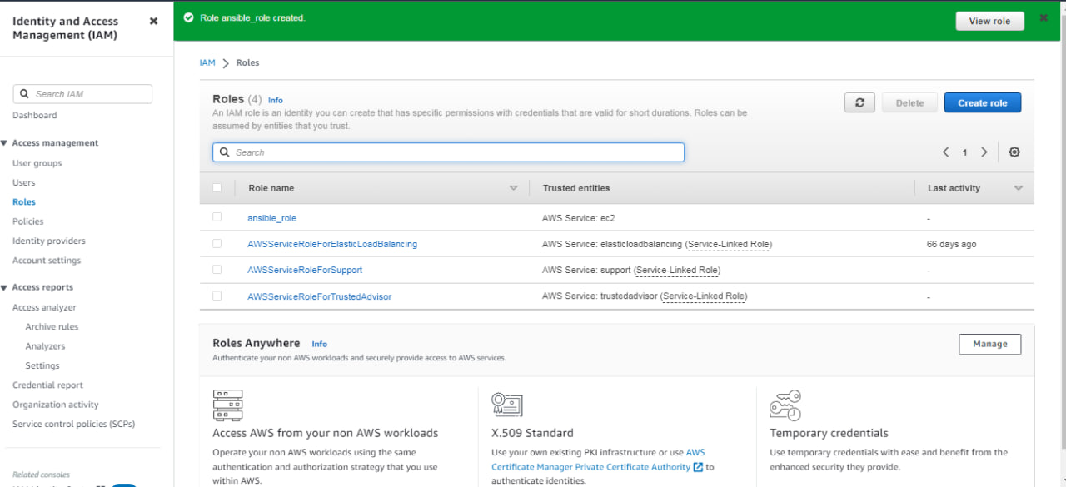

**Go to Instances and Assign IAM role**

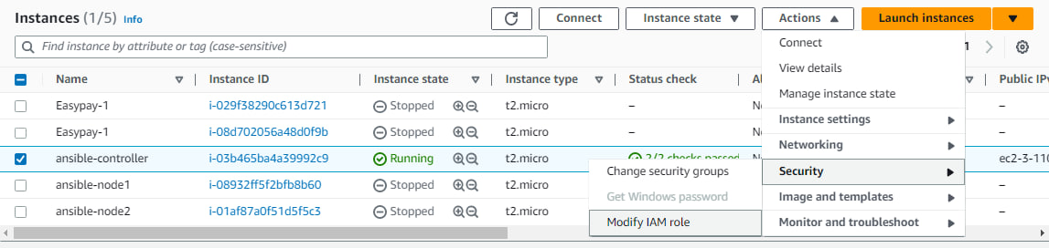

**Click on update IAM role**

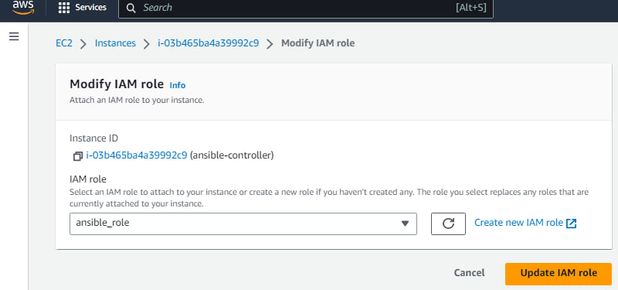

**Ansible playbook that creates an EC2 instance on AWS and performs some basic configuration tasks on it:**

$vim ansible-ec2.yaml

---

- name: Create and Configure EC2 Instance

hosts: localhost

connection: local

gather_facts: False

vars:

key_name: Mumbai

region: ap-south-1a

instance_type: t2.micro

ami: ami-0f8ca728008ff5af4

security_group: easypay-1

tasks:

- name: Launching EC2 Instance

ec2:

key_name: "{{ key_name }}"

region: "{{ region }}"

instance_type: "{{ instance_type }}"

image: "{{ ami }}"

wait: yes

group_id: "{{ security_group }}"

count: 1

instance_tags:

Name: my_instance

register: ec2

- name: Add the new instance to the host group

add_host:

name: "{{ ec2.instances[0].public_dns_name }}"

groups: launched

- name: Wait for SSH to come up

wait_for:

host: "{{ ec2.instances[0].public_dns_name }}"

port: 22

delay: 60

timeout: 320

- name: Update the apt package index

become: yes

become_user: ubuntu

apt:

update_cache: yes

- name: Install nginx web server

become: yes

become_user: ubuntu

apt:

name: nginx

state: latest

- name: Start nginx web server

become: yes

become_user: ubuntu

service:

name: nginx

state: started

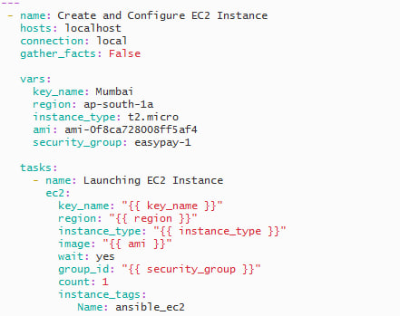

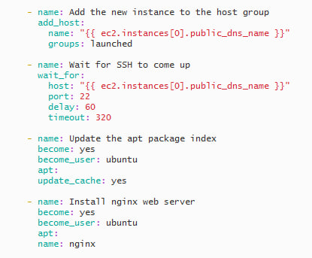

***

1. **Install Docker and Kubernetes on the cluster**

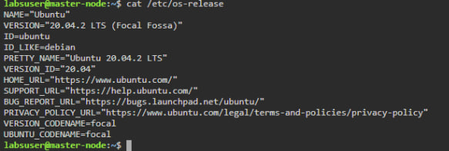

. **Install Docker**

#sudo wget #https://raw.githubusercontent.com/lerndevops/labs/master/scripts/installDocker.sh P /tmp

#sudo chmod 755 /tmp/installDocker.sh

#sudo bash /tmp/installDocker.sh

#sudo systemctl restart docker.service

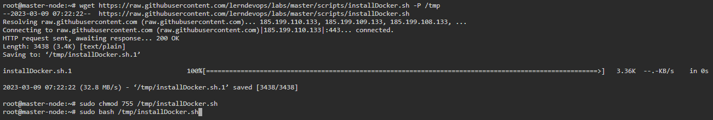

**Install CRI-Docker**

#sudo wget https://raw.githubusercontent.com/lerndevops/labs/master/scripts/installCRIDockerd.sh -P /tmp

#sudo chmod 755 /tmp/installCRIDockerd.sh

#sudo bash /tmp/installCRIDockerd.sh

#sudo systemctl restart cri-docker.service

**Install kubeadm,kubelet,kubectl**

#sudo wget https://raw.githubusercontent.com/lerndevops/labs/master/scripts/installK8S.sh -P /tmp

#sudo chmod 755 /tmp/installK8S.sh

#sudo bash /tmp/installK8S.sh

#docker -v

#cri-dockerd --version

#kubeadm version -o short

#kubelet --version

#kubectl version --short –client

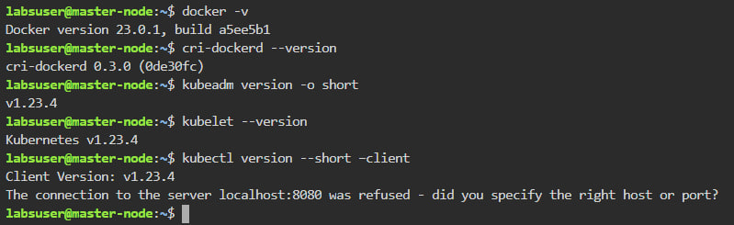

**Initialize kubernetes Master Node**

#sudo kubeadm init --cri-socket unix:///var/run/cri-dockerd.sock --ignore-preflight-errors=all

#sudo mkdir -p $HOME/.kube

#sudo cp -i /etc/kubernetes/admin.conf $HOME/.kube/config

#sudo chown $(id -u):$(id -g) $HOME/.kube/config

**Install networking driver -- Weave/flannel/canal/calico etc... below installs calico networking driver**

#kubectl apply -f https://raw.githubusercontent.com/projectcalico/calico/v3.24.1/manifests/calico.yaml

#kubectl get nodes

**Master Node to get join token**

#kubeadm token create --print-join-command

copy the kubeadm join token from master & ensure to add --cri-socket unix:///var/run/cri-dockerd.sock as below & then run on worker nodes

kubeadm join 10.128.15.231:6443 --cri-socket unix:///var/run/cri-dockerd.sock --token mks3y2.v03tyyru0gy12mbt \

--discovery-token-ca-cert-hash sha256:3de23d42c7002be0893339fbe558ee75e14399e11f22e3f0b34351077b7c4b56

#kubectl get nodes

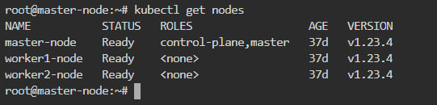

## Deploying the Dashboard UI

kubectl apply -f https://raw.githubusercontent.com/kubernetes/dashboard/v2.7.0/aio/deploy/recommended.yaml

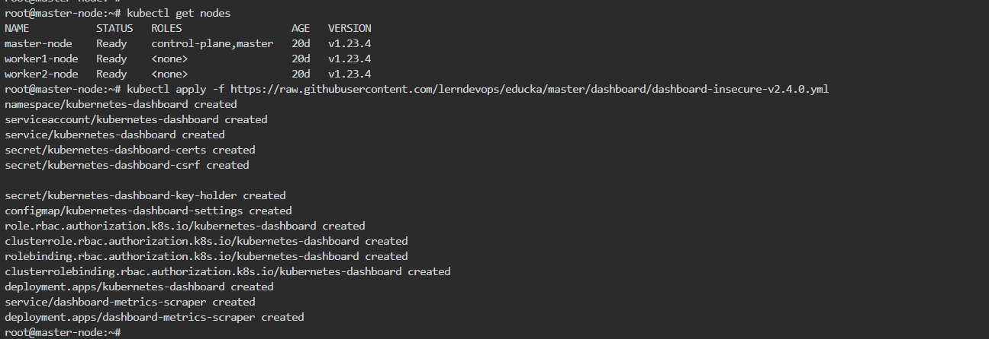

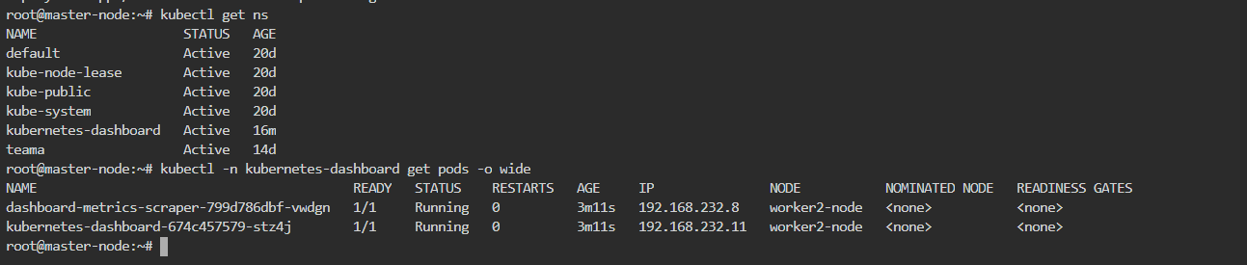

# kubectl get ns

#kubectl –n kubernetes-dashboard get pods –o wide

**4.Implement the network policies at the database pod to allow ingress traffic from the front-end application pod**

Create a Kubernetes Network Policy that allows ingress traffic from the front-end application pod to the database pod. You can define the policy in YAML format and specify the pod selector, the ingress rules, and the protocol and port to allow.

**$vim ingress.yaml**

apiVersion: networking.k8s.io/v1

kind: NetworkPolicy

metadata:

name: db-allow-front-end

spec:

podSelector:

matchLabels:

app: database

policyTypes:

- Ingress

ingress:

- from:

- podSelector:

matchLabels:

app: frontend

ports:

- protocol: TCP

port: 3306

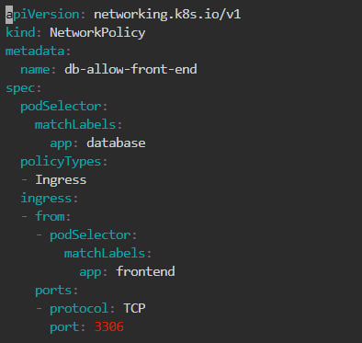

# kubectl apply –f ingress.yaml

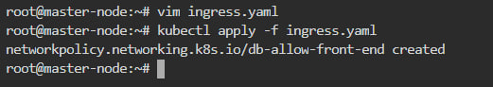

#kubectl get netpol

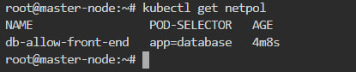

**5. To create a new user with permissions to create, list, get, update, and delete pods in Kubernetes**

**Create a new user account with a unique username and password.**

#kubectl create serviceaccount myuser

#kubectl create role myrole --verb=create,list,get,update,delete --resource=pods

#kubectl create rolebinding myuser-binding --role=myrole --serviceaccount=default:myuser

#kubectl run mypod --image=nginx --serviceaccount=myuser

**$vim pod-admin.yaml**

**Create a new role with the required permissions. For example, you can create a role named "pod-admin" with the following permissions:**

apiVersion: rbac.authorization.k8s.io/v1

kind: Role

metadata:

name: pod-admin

rules:

- apiGroups: [""]

resources: ["pods"]

verbs: ["create", "get", "list", "update", "delete"]

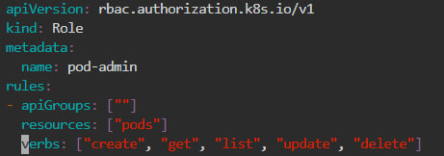

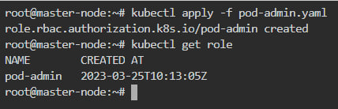

**Bind the role to the user account using a RoleBinding. For example, you can create a RoleBinding named "pod-admin-binding" to associate the "pod-admin" role with the user "newuser".**

**#vim pod-admin-binding**

apiVersion: rbac.authorization.k8s.io/v1

kind: RoleBinding

metadata:

name: pod-admin-binding

subjects:

- kind: User

name: newuser

apiGroup: rbac.authorization.k8s.io

roleRef:

kind: Role

name: pod-admin

apiGroup: rbac.authorization.k8s.io

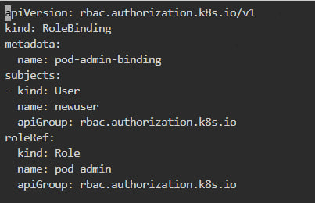

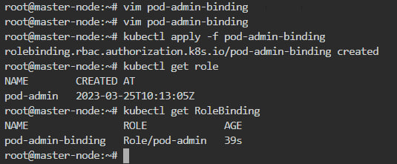

**Once you have created the user, role, and role binding, the user will have the necessary permissions to create, list, get, update, and delete pods in the Kubernetes cluster.**

**6.Configure application on the pod**

**To create the requested pods, we scale up/down**

**In Rolling update/roll back , no down time will be there.**

**# vim delploy1.yaml**

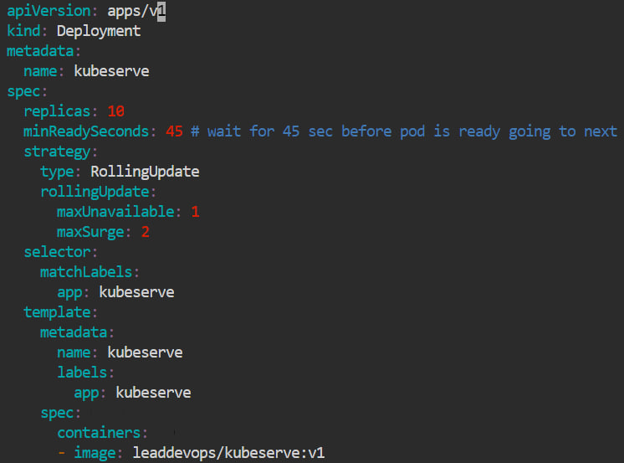

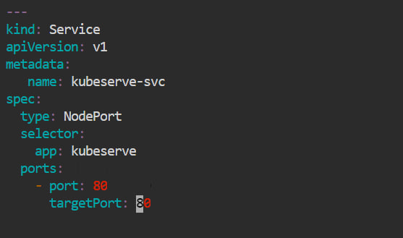

**#kubectl apply –f deploy1.yaml**

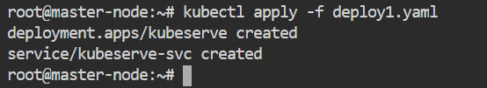

**#kubectl get pods –o wide**

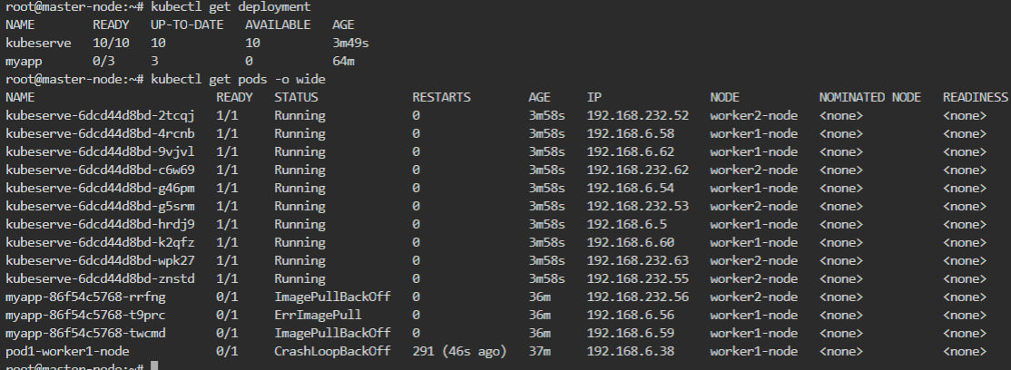

**#kubectl get services**

**#kubectl deployment –o wide**

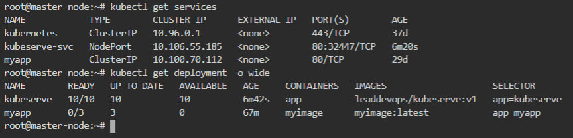

**#kubectl get replicaset –o wide**



1. **Take snapshot of ETCD database**

etcdctl --version

kubectl get pods -o wide

kubectl get pods -o wide -n kube-system

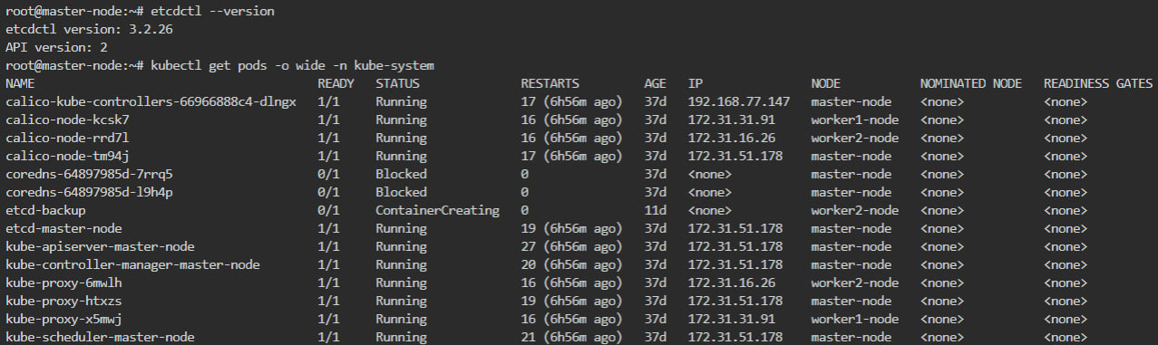

#ls -l /etc/kubernetes/pki/etcd/

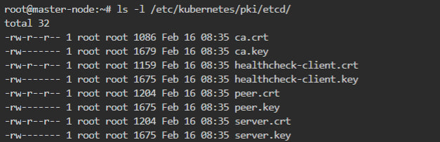

#mkdir /etcd-backup

#ETCDCTL_API=3 etcdctl --endpoints=172.31.51.178:2379 --cacert /etc/kubernetes/pki/etcd/ca.crt --cert /etc/kubernetes/pki/etcd/server.crt --key /etc/kubernetes/pki/etcd/server.key snapshot save /tmp/bakup

**To create a backup of etcd in a file /tmp/bakup with yaml file**

apiVersion: v1

kind: Pod

metadata:

name: etcd-backup

namespace: kube-system

spec:

containers:

- name: etcd-backup

image: gcr.io/etcd-development/etcdctl:v3.4.15

command:

- "/bin/sh"

- "-c"

- "ETCDCTL_API=3 etcdctl --endpoints=https:// 172.31.51.178:2379 --cacert=/etc/kubernetes/pki/etcd/ca.crt --cert=/etc/kubernetes/pki/etcd/server.crt --key=/etc/kubernetes/pki/etcd/server.key snapshot save /tmp/bakup"

volumeMounts:

- name: etcd-certs

mountPath: /etc/kubernetes/pki/etcd

readOnly: true

- name: backup-dir

mountPath: /tmp

volumes:

- name: etcd-certs

secret:

secretName: etcd-certs

- name: backup-dir

hostPath:

path: /tmp

type: DirectoryOrCreate

* 1. **Set criteria such that if the memory of CPU goes beyond 50%, environments automatically get scaled up and configured**

To set up automatic scaling of your Kubernetes environment based on CPU and memory usage, you can use Kubernetes Horizontal Pod Autoscaler (HPA). HPA can automatically adjust the number of replicas of a Deployment, ReplicaSet or StatefulSet based on the observed CPU or memory utilization of the pods.

Here are the steps to set up an HPA with a threshold of 50% CPU and memory usage:

Add resource limits to your container spec in your pod configuration file to define the maximum amount of CPU and memory that the container can use. For example:

**#vim cupapp.yaml**

apiVersion: v1

kind: Pod

metadata:

name: myapp

spec:

containers:

- name: myapp-container

image: nginx:latest

resources:

limits:

cpu: "500m"

memory: "512Mi"

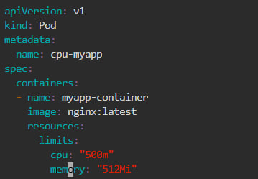

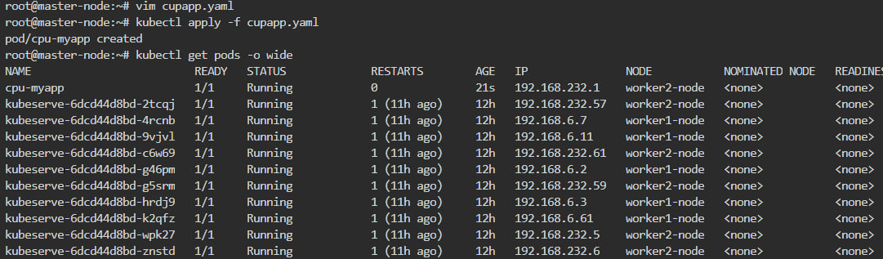

This will limit the CPU usage to 50% (500m out of 1000m) and the memory usage to 512Mi.

Create a Horizontal Pod Autoscaler (HPA) for your Deployment, ReplicaSet or StatefulSet using the kubectl autoscale command. For example:

kubectl autoscale deployment myapp-deployment --cpu-percent=50 --min=1 --max=10

This will create an HPA for the myapp-deployment with a CPU usage target of 50%, a minimum of 1 replica and a maximum of 10 replicas.

The HPA controller will monitor the CPU and memory usage of the pods and adjust the number of replicas based on the configured CPU and memory thresholds. If the CPU or memory usage exceeds 50%, the HPA will increase the number of replicas up to the maximum configured number of replicas. If the CPU or memory usage drops below 50%, the HPA will decrease the number of replicas down to the minimum number of replicas.

Note that you can also use the kubectl edit hpa command to edit the HPA configuration or manually update the number of replicas of your deployment using the kubectl scale command.

With this setup, your Kubernetes environment will automatically scale up and down based on the CPU and memory usage of your pods, ensuring that your application always has enough resources to handle the workload.

**Thank you**.